PLANNING PROPOSAL

[Subject]
85-91 Thomas Street, Parramatta

PLANNING PROPOSAL

[Subject]
85-91 Thomas Street, Parramatta

TABLE OF CONTENTS
TABLE OF CONTENTS 1
Planning Proposal drafts 1
INTRODUCTION 2
Background and context 2
PART 1 – OBJECTIVES OR INTENDED OUTCOMES 4
PART 2 – EXPLANATION OF PROVISIONS 5
1.1. Other relevant matters 5
PART 3 – JUSTIFICATION 7
3.1 Section A - Need for the planning proposal 7
3.2. Section B – Relationship to strategic planning framework 8
3.3. Section C – Environmental, social and economic impact 27
3.4. Section D – State and Commonwealth Interests 34
PART 4 – MAPPING 35
4.1 Existing controls 35
4.2 Proposed controls 45
PART 5 – COMMUNITY CONSULTATION 50
PART 6 – PROJECT TIMELINE 51
Appendix 1 – Concept Plans 52
Appendix 2 – Ecological Response 53
Appendix 3 – Traffic Report 54
Appendix 4 – VPA Offer 55

Planning Proposal drafts

Proponent versions:

No. | Author | Version
1. | ThinkPlanners | June 2016 – Initial Proposal
2. | ThinkPlanners | August 2018 – Former Revision
3. | ThinkPlanners | March 2020 – Current Scheme

Council versions:

No. | Author | Version
1. | City of Parramatta Council | Report to Local Planning Panel and Council on the assessment of planning proposal

INTRODUCTION
This Planning Proposal explains the intended effect of, and justification for, the proposed amendment to Parramatta Local Environmental Plan 2011. It has been prepared in accordance with Section 55 of the Environmental Planning and Assessment Act 1979 and the Department of Planning and Environment (DP&E) guides, 'A Guide to Preparing Local Environment Plans' (August 2016) and 'A Guide to Preparing Planning Proposals' (August 2016) and ‘Guidance for merged councils on planning functions’ (May 2016).

Background and context

On 6 June 2016, Council received a Planning proposal application from Think Planners which sought to amend the planning controls applicable to the site at 85-91 Thomas Street, Parramatta under Parramatta Local Environmental Plan 2011 (PLEP 2011). The land at 85-91 Thomas Street includes 4 Torrens title land parcels that are shown below and legally described as follows:

- Lot 13 DP 1239, known as No. 85 Thomas Street
- Lot 142 DP 537053 known as No. 87 Thomas Street
- Lot 15 DP 1239 known as No. 89 Thomas Street
- Lot 16 DP 1239 known as No 91 Thomas Street

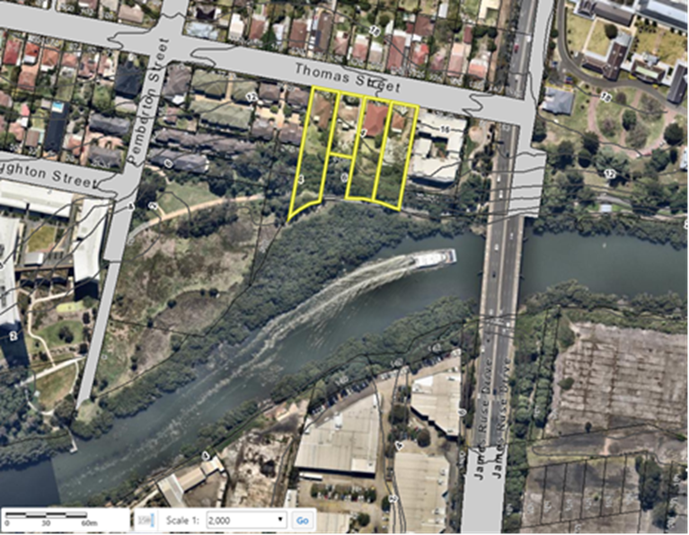
Figure 1 – Sites at 85-91 Thomas Street subject to the planning proposal

Under Parramatta Local Environmental Plan 2011 the site:
- is zoned part R4 – High Density Residential, part RE1 – Public Recreation
- has a minimum Lot Size of 550 sqm;
- has a maximum Building Height of 11 metres;
- has a maximum Floor Space Ratio (FSR) of 0.8:1;
- has a land acquisition for local open space applying to 1,296sqm of privately owned RE1 zoned land at No.85;
- 30m wide Foreshore Building Line
- Acid Sulfate Soils,
- Heritage,
- Land Reserved for Acquisition,
- Natural Resources – Biodiversity,
- Natural Resources – Riparian Lands and Waterways

An extract of each the above maps is provided in Part 4 – Mapping; specifically, Section 4.1 Existing controls.

PART 1 – OBJECTIVES OR INTENDED OUTCOMES
The objective of this Planning Proposal is to adjust the land use zoning, building height and floor space ratio on the site at 85-91 Thomas Street to accommodate a residential flat building development within the developable portion of the site. In order to accommodate the gross floor area of 0.8:1 across the privately owned site, there will be an adjustment in land use zoning boundaries, increase in maximum building height and maximum floor space ratio for the proposed R4 land.

The owners of the subject site (Century 888 Pty Ltd) authorised ThinkPlanners to submit the original Planning Proposal in June 2016 to coordinate the matters relating to the subject site and this rezoning application.

The Planning Proposal intends to deliver the following outcomes for the site:
- Accommodate high-density residential development up to 4,973sqm outside the undevelopable portions of the site
- Locate the building envelope and mass the Gross Floor Area within the developable portion of the site,
- Accommodate similar amount of GFA on the site as permitted by the planning controls prior to Parramatta LEP 2011 – Amendment No.20 Review
- Dedicate land identified for acquisition, public open space and natural resources.

PART 2 – EXPLANATION OF PROVISIONS
This planning proposal seeks to amend Parramatta LEP 2011 (PLEP 2011) in relation to the zoning and height controls.

In order to achieve the desired objectives the following amendments to the PLEP 2011 would need to be made:

- Amend the Land Zoning Map to maintain the R4 – High Density Residential zone for the developable part of the site (3,825sqm) and extending the RE1 – Public Recreation zone for the undevelopable land affected by the Natural Resources - Biodiversity controls. (Sheet LZN_[010]).

- Amend the maximum building height in the Height of Buildings Map (Sheet HOB_010) from 11 metres to 22 metres that equates to 6 storeys for the proposed R4 land within the developable area of the site. Removing the Height of Buildings control for the proposed RE1 land.

- Amend the maximum floor space ratio in the Floor Space Ratio Map (Sheet FSR_010) from 0.8:1 to 1.3:1 for the proposed R4 land within the developable area of the site. Removing the Floor Space Ratio control for the proposed RE1 land.

- Remove the acquisition affectation from No.85 Thomas should this be dedicated to Council.

Other relevant matters
    - Voluntary Planning Agreement
The subject site and proposed development uplift being sought lends itself to the provision of public benefits, consistent with Council’s Planning Agreements policy. The proponent expressed interest into entering a Voluntary Planning Agreement consistent with the policy. The applicant submitted a Letter of Offer on 8 August 2018. The applicant is currently proposing the following VPA item:
  - Dedication 2,496sqm of privately owned land identified for land acquisition (open space) or natural resources (biodiversity) to Council within the undevelopable part of the site at the south.

Under Council’s Planning Agreements Policy, planning proposals outside the Parramatta CBD seeking uplift in density need to be supported by a planning agreement that is valued at 50% of the resulting land value uplift. It is acknowledged that the gazettal of Amendment 20 reduced the development potential on the site and the planning proposal is only seeking to recoup the density potential it may have been able to achieve under the planning controls in place prior to this amendment. Based on an acceptance of this approach, it is not considered necessary to seek a planning agreement achieving 50% land value uplift, as there is effectively no increase in overall development potential of the site. It is also acknowledged that the site may not have been able to achieve the full density potential under the previous planning controls due to the constrained nature of the southern portion of the site, however the previous controls did allow development on this part of the site and the gazettal of Amendment 20 removed that potential.

In addition, the Planning Agreement is proposing to dedicate land that is identified for acquisition under PLEP 2011 free of cost, thereby removing an acquisition burden on Council. Without the Planning Proposal and associated Planning Agreement, Council would ultimately be required to purchase the land from the owner. The Planning Agreement is also proposing to dedicate the undevelopable portion of the R4 High Density Residential zoned land to Council free of cost. This land is intended to provide a contiguous vegetation buffer along the rear of the site with the adjacent RE1 Public Recreation land. It is therefore recommended that this portion of the R4 High Density Residential zoned be rezoned to RE1 Public Recreation to match the adjoining land and to properly reflect its intended use.
It is recommended that Council authorise the CEO to enter into VPA Negotiations with the applicant

    - Draft Development Control Plan
Given the nature of redevelopment proposed on the site, a site-specific Development Control Plan (DCP) will be required to support any future development on the site. The site-specific DCP would guide the redevelopment of the site, having regard to the local context and detailed design requirement for the site, including, but limited to the following:
  - Built Form and Massing
  - Solar Access and Overshadowing
  - Traffic, Transport and Parking
  - Landscaping and Open Space
Both the draft Voluntary Planning Agreement and draft Development Control Plan will be exhibited concurrently as part of the public exhibition stage following Gateway Determination.

PART 3 – JUSTIFICATION
This part describes the reasons for the proposed outcomes and development standards in the planning proposal.

Section A - Need for the planning proposal
- This section establishes the need for a planning proposal in achieving the key outcome and objectives. The set questions address the strategic origins of the proposal and whether amending the LEP is the best mechanism to achieve the aims on the proposal.
    - Is the planning proposal a result of an endorsed local strategic planning statement, strategic study or report?
Yes, the Planning Proposal responds to the State Government’s initiatives for growth in the Greater Sydney Commission’s Greater Parramatta and Olympic Peninsula (GPOP) area and Department of Planning Industry and Environment’s (DPIE) draft Greater Parramatta Growth Area which is in close proximity to the site. The GPOP area is an approximate area which will broadly experience significant growth and change over the next 20 years (see Figure 2).

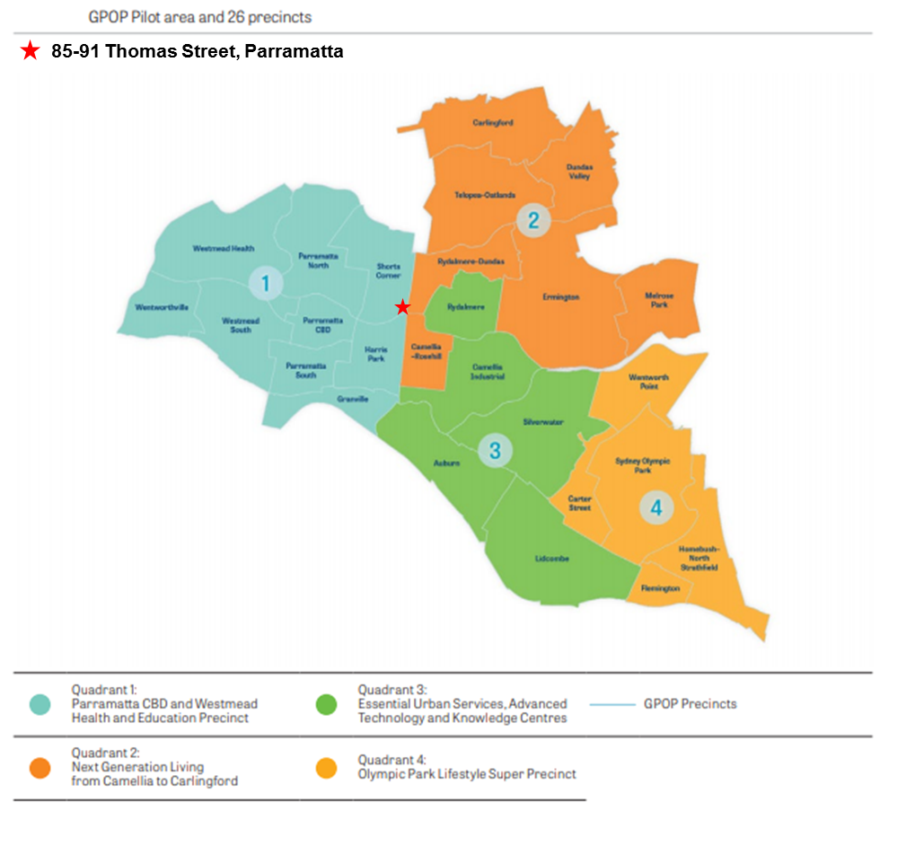
Figure 2– Subject site within GPOP

    - Is the Planning Proposal the best means of achieving the objectives or intended outcomes, or is there a better way?
Redevelopment of the site for the site under the Planning Proposal reinstates the amount of permissible high-density floor space permitted on the site when the Planning Proposal was lodged in June 2016, and prior to Parramatta LEP 2011 –Amendment No.20 Review of Land Reserved for Acquisition which was gazette on 28 July 2017. This amendment ezoned R4 land at No.85 Thomas Street to RE1 – public recreation with a Land Acquisition affection for local open space. No.89 and No.91 were also affected by Amendment No.20 which identified 1,200sqm of R4 land for Natural Resources controls, making this portion of the site undevelopable, but able to be used for calculating FSR.

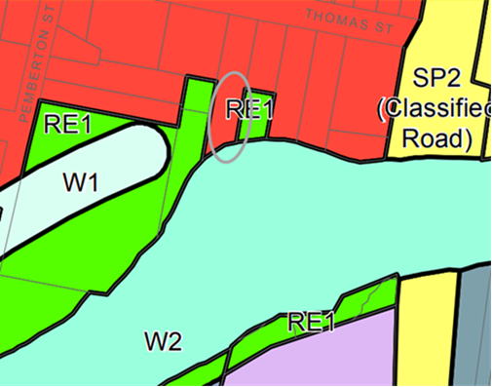
Figure 3 - Zoning of site prior to PLEP 2011 Amendment No.20

Prior to this amendment, 5,057sqm of GFA was permitted under 0.8:1 FSR across the site. The current planning controls allow a maximum of 4,020sqm of GFA is permitted. The Planning Proposal proposed changes in land use zoning boundaries to reflect the developable portions of the site, increase in maximum building height and increase maximum floor space ratio controls. These changes could accommodate approximately 4,973sqm of GFA across the developable site area, which is a lower GFA than what was permissible on the site when the PP was lodged.It also allows for the undevelopable portion of the site to be dedicated for public recreation and natural resources land.
The redevelopment would see 55-59 apartment dwellings accommodated on the site, which is equal to or lower than what was permissible on the site when the Planning proposal was lodged. A change in building height provides opportunities for the previously permissible floor space provision to be accommodated on the site.

Section B – Relationship to strategic planning framework
This section assesses the relevance of the Planning Proposal to the directions outlined in key strategic planning policy documents. Questions in this section consider state and local government plans including the NSW Government’s Plan for Growing Sydney and subregional strategy, State Environmental Planning Policies, local strategic and community plans and applicable Ministerial Directions.

    - Will the planning proposal give effect to the objectives and actions of the applicable regional, or district plan or strategy (including any exhibited draft plans or strategies)?
A Metropolis of Three Cities
In March 2018, the NSW Government released the Greater Sydney Region Plan: A Metropolis of Three Cities (“the GSRP”) a 20 year plan which outlines a three-city vision for metropolitan Sydney for to the year 2036.

The GSRP is structured under four themes: Infrastructure and Collaboration, Liveability, Productivity and Sustainability. Within these themes are 10 directions that each contain Potential Indicators and, generally, a suite of objective/s supported by a Strategy or Strategies. Those objectives and or strategies relevant to this planning proposal are discussed below.

Infrastructure and Collaboration
An assessment of the planning proposal’s consistency with the GSRP’s relevant Infrastructure and Collaboration objectives is provided in Table 3a, below.

Table 3a – Consistency of planning proposal with relevant GSRP Actions – Infrastructure and Collaboration
Infrastructure and Collaboration Direction | Relevant Objective | Comment
A city supported by infrastructure | O1: Infrastructure supports the three cities | The Region Plan highlights that the Central River City is undergoing a rebuilding program in a high-growth environment, which required existing infrastructure to be optimised. Redevelopment of the existing R4 zoned site in close proximity to James Ruse Drive and Parramatta Valley Cycleway to accommodate a maximum of 6-storey development hopes to maximise the 4,973sqm GFA, which is slightly below the GFA previously permissible on the site prior to PLEP 2011 – Amendment No.20 when the Planning Proposal was lodged. A VPA will also be negotiated aside this Planning Proposal once the strategic parameters and planning controls have been set.
 | O2: Infrastructure aligns with forecast growth – growth infrastructure compact
 | O3: Infrastructure adapts to meet future need
 | O4: Infrastructure use is optimised

Liveability
An assessment of the planning proposal’s consistency with the GSRP’s relevant Liveability objectives is provided in Table 3b, below.

Table 3b – Consistency of planning proposal with relevant GSRP Actions – Liveability
Liveability Direction | Relevant Objective | Comment
A city for people | O6: Services and infrastructure meet communities’ changing needs | The Planning Proposal hopes to optimise land identified for future public open space and existing natural resources (biodiversity & riparian lands and waterways). The PP allocates GFA under a change to zone boundaries for high-density and public recreation land use zones to reflect the developable site area, and increases to maximum HOB and FSR controls to accommodate 4,972sqm, which is slightly below the GFA which could be accommodated on the site when the PP was lodged, prior to PLEP 2011 – Amendment No.20.
 | O7: Communities are healthy, resilient and socially connected
 | O8: Greater Sydney’s communities are culturally rich with diverse neighbourhoods
 | O9: Greater Sydney celebrates the arts and supports creative industries and innovation
Housing the city | O10: Greater housing supply | The subject site is situated outside Council’s already identified growth precincts and currently zoned high-density residential . The PP proposes to accommodate 59 apartment dwellings under an increase in height up to 22m and increase in FSR across the developable portion up to 1.3:1. The PP also removes HOB, FSR and LRA controls for the area identified for land dedication. The reference design accommodates 4,973sqm of high-density residential GFA, which is below what could have been achieved when the PP was lodged.
 | O11: Housing is more diverse and affordable | Given the site is already zoned R4 – High Density Residential where residential flat buildings are already permitted, and that the Planning Proposal is not seeking a significant uplift over and above what the site could previously achieve, the Planning Proposal is considered to be consistence with this objective and Council’s LSPS in this instance.  It is anticipated that City of Parramatta is expected to meet and potentially exceed its housing targets set by the Greater Sydney Commission, thus the change in planning controls must be justified in accordance with other Liveability Directions.
A city of great places | O12: Great places that bring people together | The site is situated in close proximity to the Parramatta River, Western Sydney University and the periphery of Parramatta CBD which provide opportunities to future residents for employment, education and recreation.
 | O13: Environmental heritage is identified, conserved and enhanced | Parts of the site are identified for natural resources-biodiversity, natural resources – riparian lands and waterways and environmental heritage I1- Wetlands Parramatta River. Future development on the site will be located away from these sensitive environmental areas.

Productivity
An assessment of the planning proposal’s consistency with the GSRP’s relevant Productivity objectives is provided in Table 3c, below.

Table 3c – Consistency of planning proposal with relevant GSRP Actions – Productivity
Productivity Direction | Relevant Objective | Comment
A well connected city | O14: The plan integrates land use and transport creates walkable and 30 minute cities | The site is located in close proximity to James Ruse Drive, Parramatta Valley Cycleway which connect to Parramatta CBD nearby. The increase in building height to accommodate high-density residential dwellings supports integrating land use with walkable 30min cities to the Central River City of Parramatta.
 | O15: The Eastern, GPOP and Western Economic Corridors are better connected and more competitive | The subject site is located within the Shorts Corner precinct of GPOP. This precinct is not identified for growth as part of Phase 1 or Phase 2 of the Place-based Infrastructure Compact. The PP does not see an increase in residential GFA above what was previously permitted on the site at lodgement of the PP\.
Jobs and skills for the city | O19: Greater Parramatta is stronger and better connected | This Planning Proposal is generally consistent with the vision under O19 of the region plan. An increase in building height allows for the GFA previously available under the zoning prior to 28 July 2017 to be massed within a 6-storey built form.
 | O21: Internationally competitive health, education, research and innovation precincts | The Planning Proposal does not seek to allow for employment floor space. The application adjusts the area boundaries affected by R4 – High Density Residential and RE1 – Public Recreation to reflect the developable areas of the site and land dedication.
 | O22: Investment and business activity in centres
 | O23: Industrial and urban services land is planned, retained and managed
 | O24: Economic sectors are targeted for success

Sustainability
An assessment of the planning proposal’s consistency with the GSRP’s relevant Sustainability objectives is provided in Table 3d, below.

Table 3d – Consistency of planning proposal with relevant GSRP Actions – Sustainability

Sustainability Direction | Relevant Objective | Comment
A city in its landscape | O25: The coast and waterways are protected and healthier | The subject site included planning affections from Natural Resources – Riparian Lands and Waterways & Biodiversity and the Foreshore Building Line along the southern portion of the site. The reference design locates the future building envelope outside the affected areas on the elevated topography at the north of the site. The southern portion of the site would be rezoned RE1 and dedicated to Council.  Concerns were raised in the initial assessment regarding the coastal mangroves and saltmarshes. Department of Primary Industries indicated in November 2017 that “does not see any reason for potential shading  issues on mangrove and saltmarsh species to prevent the lodgement of this development, as proposed”
 | O27: Biodiversity is protected, urban bushland and remnant vegetation is enhanced
 | O28: Scenic and cultural landscapes are protected | The proposal is situated in close proximity to Parramatta River. A substantial setback is proposed for future development that locates the building out of the Foreshore Building Line, Natural Resources affectation and heritage area.
 | O29: Environmental, social and economic values in rural areas are protected and enhanced | N/A
 | O30: Urban tree canopy cover is increased | Deep soil areas are proposed for the front and side setbacks. A site specific DCP proposed to accommodate urban tree canopy cover on the site to enhance the streetscape and improve privacy between neighbouring properties.
 | O31: Public open space is accessible, protected and enhanced | The subject site includes an acquisition for local open space on No.85 Thomas Street. The subject site is also subject to an easement for the Parramatta Valley Cycleway along the southern edge of the site.
 | O32: The Green grid links Parks, open spaces, bushland and walking and cycling paths | The subject site already includes elements of the green grid along the southern portion of the site within the natural resourced affected land where the Parramatta Valley cycleway is located.
An efficient city | O33: A low-carbon city contributes to net-zero emissions by 2050 and mitigates climate change | The proposal does not include sustainability initiatives such as recycled water, sustainable building materials, photovoltaics. Should the proposal proceed, initiatives towards net-zero emission by 2050, methods of recycling construction and ongoing waste should be investigated as part of the Development Application stage. Further consideration should be given to council’s environmental sustainability strategy when delivering the proposal.
 | O34: Energy and water flows are captured, used and re-used
 | O35: More waste is re-used and recycled to support the development of a circular economy
A resilient city | O36: People and places adapt to climate change and future shocks and stresses | The proposal does include some flood affected land. However, the proposed building is located away from the land impacted by natural hazards.
 | O37: Exposure to natural and urban hazards is reduced
 | O38: Heatwaves and extreme heat are managed

Implementation
An assessment of the planning proposal’s consistency with the GSRP’s relevant Implementation objectives is provided in Table 3d, below.

Table 3d – Consistency of planning proposal with relevant GSRP Actions – Implementation
Implementation Direction | Relevant Objective | Comment
Implementation | O39: A collaborative approach to city planning | The proposal is responding to in depth consultation between Council, the applicant and Department of Primary Industries.

Central City District Plan
In March 2018, the NSW Government released Central City District Plan which outlines a 20 year plan for the Central City District which comprises The Hills, Blacktown, Cumberland and Parramatta local government areas.

Taking its lead from the GSRP, the Central City District Plan (“CCDP”) is also structured under four themes relating to Infrastructure and Collaboration, Liveability, Productivity and Sustainability. Within these themes are Planning Priorities that are each supported by corresponding Actions. Those Planning Priorities and Actions relevant to this planning proposal are discussed below.

Infrastructure and Collaboration
An assessment of the planning proposal’s consistency with the CCDP’s relevant Infrastructure and Collaboration Priorities and Actions is provided in Table 4a, below.

Table 4a – Consistency of planning proposal with relevant CCDP Actions – Infrastructure and
Collaboration
Infrastructure and Collaboration Direction | Planning Priority/Action | Comment
A city supported by infrastructure  O1: Infrastructure supports the three cities  O2: Infrastructure aligns with forecast growth – growth infrastructure compact  O3: Infrastructure adapts to meet future need  O4: Infrastructure use is optimised | PP C1: Planning for a city supported by infrastructure  - A1: Prioritise infrastructure investments to support the vision of A metropolis  - A2: Sequence growth across the three cities to promote north-south and east-west connections  - A3: Align forecast growth with infrastructure  - A4: Sequence infrastructure provision using a place based approach  - A5: Consider the adaptability of infrastructure and its potential shared use when preparing infrastructure strategies and plans  - A6: Maximise the utility of existing infrastructure assets and consider strategies to influence behaviour changes to reduce the demand for new infrastructure, supporting the development of adaptive and flexible regulations to allow decentralised utilities | The site located on Thomas Street is in close proximity to the James Ruse Drive regional route and Parramatta Valley Cycleway. The site may be easily accessed via car, bus or bicycle. The proposal arranges the currently permissible high-density residential use within the northern half of the subject site in hope to utilise the existing assets at the south for natural resources and public open space.
O5: Benefits of growth realized by collaboration of governments, community and business | PP C2: Working through collaboration  - A7: Identify prioritise and delivery collaboration areas

Liveability
An assessment of the planning proposal’s consistency with the CCDP’s relevant Liveability Prioirties and Actions is provided in Table 4b, below.

Table 4b – Consistency of planning proposal with relevant CCDP Actions – Liveability
Liveability Direction | Planning Priority/Action | Comment
A city for people  O6: Services and infrastructure meet communities’ changing needs | PP C3: Provide services and social infrastructure to meet people’s changing needs  - A8: Deliver social infrastructure that reflects the need of the community now and in the future  - A9: Optimise the use of available public land for social infrastructure | As part of the proposal, the application proposed to dedicate 1,296sqm land at No.85 Thomas Street for public open space as identified in the land reserved for acquisition map and 1,200sqm of land at No.89 and 91 Thomas Street identified for Natural Resources –Riparian Lands and Waterways & Biodiversity for council ownership.
O7: Communities are healthy, resilient and socially connected  O8: Greater Sydney’s communities are culturally rich with diverse neighbourhoods  O9: Greater Sydney celebrates the arts and supports creative industries and innovation | PP C4: Working through collaboration  - A10: Deliver healthy, safe and inclusive places for people of all ages and abilities that support active, resilient and socially connected communities by (a-d).  - A11: Incorporate cultural and linguistic diversity in strategic planning and engagement.  - A12: Consider the local infrastructure implications of areas that accommodate large migrant and refugee populations.  - A13: Strengthen the economic self-determination of Aboriginal communities by engagement and consultation with Local Aboriginal Land Council’s.  - A14: Facilitate opportunities for creative and artistic expression and participation, wherever feasible with a minimum regulatory burden including (a-c).  - A15: Strengthen social connections within and between communities through better understanding of the nature of social networks and supporting infrastructure in local places | The initial application has been referred to the former Department of Primary Industries for comment on the sensitive ecology areas to the south as identified in the Natural Resources and Heritage Map. The input from state government agencies has assisted in preparing a supportable scheme.  Council’s LEP Amendment No.20 relating to Land Reserved for Acquisition has also affected the application identifying parts of the site for public recreation and natural resources biodiviersity/riparian lands and waterways. This impacted the developable of the R4 zoned site. This Planning Proposal hopes to facilitate development in accordance with the intentions of the controls of the site.
Housing the city  O10: Greater housing supply  O11: Housing is more diverse and affordable | PP C5: Providing housing supply, choice and affordability, with access to jobs, services and public transport  - A16: Prepare local or district housing strategies that address housing targets [abridged version]  - A17: Prepare Affordable Rental housing Target Schemes | City of Parramatta is expected to meet and potentially exceed its housing targets set by the Greater Sydney Commission, thus the change in planning controls cannot be justified under O10 which proposes to increase the supply of housing.  A Planning Proposal increasing the maximum building height provides an opportunity for the applicant to obtain Gross Floor Area (GFA) for high-density residential uses from the undevelopable land zoned R4 and, and in this exceptional circumstance the privately owned RE1 portion rezoned by a Council let proposal.  No affordable housing is included in the planning proposal at this stage. The proposal could investigate potential to include future affordable housing stock on the site under Council’s Affordable Housing Policy.
A city of great places  O12: Great places that bring people together  O13: Environmental heritage is identified, conserved and enhanced | PP C6: Creating and renewing great places and local centres, and respecting the District’s heritage  - A18: Using a place-based and collaborative approach throughout planning, design, development and management deliver great places by (a-e)  - A19: Identify, conserve and enhance environmental heritage by (a-c)  - A20: Use place-based planning to support the role of centres as a focus for connected neighbourhoods  - A21: In Collaboration Areas, Planned Precincts and planning for centres (a-d)  - A22: Use flexible and innovative approaches to revitalise high streets in decline. | The site reference scheme proposed a design that masses the building envelope within the developable portion of the site in the northern half of the site. It provides separation between the development and existing environmental constraints such as the open space acquisition, natural resources area and Parramatta River.

Productivity
An assessment of the planning proposal’s consistency with the CCDP’s relevant Productivity Priorities and Actions is provided in Table 4c, below.

Table 4c – Consistency of planning proposal with relevant CCDP Actions – Productivity
Productivity Direction | Planning Priority/Action | Comment
A well-connected city  O19: Greater Parramatta is stronger and better connected | PP C7: Growing a stronger and more competitive Greater Parramatta  - A23: Strengthen the economic competitiveness of Greater Parramatta and grow its vibrancy [abridged]  - A24: Revitalise Hawkesbury Road so that it becomes the civic, transport, commercial and community heart of Westmead  - A25: Support the emergency services transport, including helicopter access  - A26: Prioritise infrastructure investment [abridged]  - A27: Manage car parking and identify smart traffic management strategies  - A28: Investigate opportunities for renewal of Westmead East as a mixed use precinct | The existing R4 zoned site is located in close proximity to the Parramatta CBD and intends to deliver additional high-density residential dwellings in close proximity to the employment generating uses in Parramatta CBD.  Redevelopment for high-density residential uses on the site is subject to significant environmental and topographic restraints to the southern portion of the site. The Planning Proposal, site-specific DCP and draft VPA endeavour to address the highly restrained environmental condition of the site within an R4 zoning in close proximity to Parramatta CBD.
Jobs and skills for the city  O15: The Eastern, GPOP and Western Economic Corridors are better connected and more competitive | PP C8: Delivering a more connected and competitive GPOP Economic Corridor  - A28: Investigate opportunities for renewal of Westmead East as a mixed use precinct PPC8  - A29: Prioritise public transport investment to deliver the 30-minute city objective for strategic centres along the GPOP Economic Corridor  - A30: Prioritise transport investments that enhance access to the GPOP between centres within GPOP | The proposal maintains the existing R4 – High Density Residential zone for the subject site across the developable area at the northern porton of the site along the street, and extends the existing RE1 –Public Recreation use across the undeveloped site area which is proposed for land dedication. The site is located within the GPOP corridor and in a location near local bus routes, regional highways and local cycleways that supports the 30-minute city.
O14: The plan integrates land use and transport creates walkable and 30 minute cities | PP C9: Delivering integrated land use and transport planning and a 30-minute city  - A32: Integrate land use and transport plans to deliver a 30-muinute city  - A33: Investigate, plan and protect future transport and infrastructure corridors  - A34: Support innovative approaches to the operation of business, educational and institutional establishments to improve the performance of the transport network  - A35: Optimise the efficiency and effectiveness of the freight handling and logistics network by (a-d)  - A36: Protect transport corridors as appropriate, including the Western Sydney Freight Line, North South train link from Schofields to WS Airport as well as Outer Sydney Orbital and Bells Line of Road-Castlereagh connections
O23: Industrial and urban services land is planned, retained and managed | PP C10: Growing investment, business opportunities and jobs in strategic centres  - A37: Provide access to jobs, goods and services in centres [abridged]  - A38: Create new centres in accordance with the principles for Greater Sydney’s centres  - A39: Prioritise strategic land use and infrastructure plans for growing centres, particularly those with capacity for additional floorspace | The Planning Proposal would locate additional housing in close proximity to the Parramatta CBD. It is anticipated that additional housing will grow investment and business opportunities for everyday retail and commercial uses at the site and is therefore consistent with PP C10.
O23: Industrial and urban services land is planned, retained and managed | PP C11: Maximising opportunities to attract advanced manufacturing and innovation in industrial and urban services land | N/A
O24: Economic sectors are targeted for success | PP C12: Supporting growth of targeted industry sectors | N/A

Sustainability
An assessment of the planning proposal’s consistency with the CCDP’s relevant Productivity Prioirties and Actions is provided in Table 4d, below.

Table 4d – Consistency of planning proposal with relevant CCDP Actions – Sustainability
Sustainability Direction | Planning Priority/Action | Comment
A city in its landscape  O25: The coast and waterways are protected and healthier | PP C13: Protecting and improving the health and enjoyment of the District’s Waterways  - A60: Protect environmentally sensitive areas of waterways  - A61: Enhance sustainability and liveability by improving and managing access to waterways and foreshores for recreation, tourism, cultural events and water based transport  - A62: Improve the health of catchments and waterways through a risk based approach to managing the cumulative impacts of development including coordinated monitoring of outcomes  - A63: Work towards reinstating more natural conditions in highly modified urban waterways | The proposal is situated adjacent to Parramatta River. A substantial setback is proposed for future development that locates the building out of the Foreshore Building Line, Natural Resources affectation and heritage area. The reference design proposed positions future development outside the affected areas on the elevated topography at the north of the site.
O26: The coast and waterways are protected and healthier | PP C14: Creating a Parkland City urban structure and identity, with South Creek as a defining spatial element  - A64: Implement South Creek Corridor Project and use the design principles for South Creek to deliver a cool and green Western Parkland City | The subject site is adjacent to the Parramatta River and impacted by the Coastal Management SEPP 2018. The Foreshore Building Line in the LEP also affects the subject site.
O27: Biodiversity is protected, urban bushland and remnant vegetation is enhanced  O28: Scenic and cultural landscapes are protected | PP C15: Protecting and enhancing bushland, biodiversity and scenic and cultural landscapes  - A65: Protect and enhance biodiversity by (a-c) [abridged]  - A66: Identify and protect scenic and cultural landscapes  - A67: Enhance and protect views of scenic and cultural landscapes from the public realm | The subject site includes urban bushland which is classified as Natural Resources – Riparian Lands and Waterways. This has been taken into consideration when preparing the reference design for the planning proposal, which includes both developable and undevelopable portions to the site.
O30: Urban tree canopy cover is increased  O32: The Green grid links Parks, open spaces, bushland and walking and cycling paths | PP C16: PP C16: Increasing urban tree canopy cover and delivering Green grid connections  - A68: Expand urban tree canopy in the public realm  - A69: progressively refine the detailed design and delivery of (a-c) [abridged]  - A70: Create Greater Sydney green Grid connections to the Western Sydney Parklands | The subject site already includes urban tree canopy within the southern portion of the site. This area is anticipated to be maintained as existing as part of the planning proposal.  Deep soil areas are proposed for the front and side setbacks. A site specific DCP proposed to accommodate urban tree canopy cover on the site to enhance the streetscape and improve privacy between neighbouring properties.
O31: Public open space is accessible, protected and enhanced | PP C17: Delivering high quality open space  - A71: Maximise the use of existing open space and protect, enhance and expand public open space by (a-g) [abridged] | The subject site includes an acquisition for local open space on No.85 Thomas Street. The subject site is also subject to an easement for the Parramatta Valley Cycleway along the southern edge of the site. The easement will be maintained as part of the future development.  The Planning Agreement Offer also includes land dedication for the existing RE1 land affected by a land acquisition (1,296sqm) and natural resources biodiversity land (1,200sqm).
An efficient city  O33: A low-carbon city contributes to net-zero emissions by 2050 and mitigates climate change  O34: Energy and water flows are captured, used and re-used  O35: More waste is re-used and recycled to support the development of a circular economy | PP C19: Reducing carbon emissions and managing energy, water and waste efficiently  - A75: Support initiatives that contribute to the aspirational objectives of achieving net-zero emissions by 2050  - A76: Support precinct-based initiatives to increase renewable energy generation and energy and water efficiency  - A77: Protect existing and identify new locations for waste recycling and management  - A78: Support innovative solutions to reduce the volume of waste and reduce waste transport requirements  - A79: Encourage the preparation of low carbon, high efficiency strategies to reduce emissions, optimise the use of water, reduce waste and optimising car parking provisions where an increase in total floor in 100,000sqm | The proposal does not include sustainability initiatives such as recycled water, sustainable building materials, photovoltaics. Should the proposal proceed, initiatives towards net-zero emission by 2050, methods of recycling construction and ongoing waste should be investigated as part of the Development Application stage. Further consideration should be given to council’s environmental sustainability strategy when delivering the proposal.
O36: People and places adapt to climate change and future shocks and stresses  O37: Exposure to natural and urban hazards is reduced  O38: Heatwaves and extreme heat are managed | PP C20: Adapting to the impacts of urban and natural hazards and climate change  - A81: Support initiatives that respond to the impacts of climate change  - A82: Avoid locating new urban development in areas exposed to natural and urban hazards and consider options to limit the intensification of development in existing areas most exposed to hazards  - A83: Mitigate the urban heat island effect and reduce the vulnerability to extreme heat  - A84: Respond to the direction for managing flood risk in Hawkesbury-Nepean Valley  - A85: Consider strategies and measures to manage flash flooding and safe evacuation when planning for growth in Parramatta CBD | The proposal does include some flood affected land. However, the proposed building envelope in the reference design is located away from the land impacted by natural hazards.

    - Will the planning proposal give effect to a council’s endorsed local strategic planning statement, or another endorsed local strategy or strategic plan?
The following local strategic planning documents are relevant to the planning proposal.

Parramatta 2038 Community Strategic Plan
Parramatta 2038 is a long term Community Strategic Plan for the City of Parramatta and it links to the long-term future of Sydney. The plan formalises several big and transformational ideas for the City and the region. The planning proposal is considered to meet the strategies and key objectives identified in the plan including:
- 3.4 Provide green spaces for recreation, relaxation and enjoyment
- 6.1 Engage in strategic planning and implement innovative solutions to manage the growth of our city

Parramatta Local Strategic Planning Statement
The LSPS sets out the long-term vision for land use planning in a council’s local government area (LGA) and responds to broader priorities identified in the District Plans and integrates with a Council’s Community Strategic Plan. The LSPS will provide greater weight to strategic planning in the broader plan making process and any new planning proposal must justify any inconsistency with this framework.

The Planning Proposal is assessed against the broad directions of the LSPS as shown below in Table 5.

Table 5: LSPS Assessment
Broad Directions of LSPS | Comment
- Focus employment growth in the Parramatta Metropolitan Centre (Parramatta CBD) and Strategic Centres of Epping and Sydney Olympic Park and Westmead Innovation Precinct | N/A
- Housing growth is focused in identified Growth Precincts | The site is not within an already identified housing growth precinct in Council’s LSPS, Council’s LHS or the GPOP Place-based infrastructure compact. The site is already zoned R4 – High Density Residential. Prior to Parramatta LEP 2011 – Amendment No.20, the entire 6,321sqm of privately owned land had a 0.8:1 FSR allowing up to 5057sqm of GFA . This Planning Proposal redistributes that previously available floorspace within the developable portion of the site (3,825sqm) in an increased height limit of 22m and increase FSR of 1.3:1 applying to the R4 land.
- Preserve and enhance the low-scale character and identity of suburban City of Parramatta suburbs outside of the GPOP area | Residential flat buildings are already a permissible use on the subject site. The planning proposal does not propose to change the R4 zoning of the developable portion of the site. The reference design provides substantial setbacks exceeding what would be required by the Apartment Design Guide to better protect the amenity and privacy of adjoin R4 zoned sites, some which still include single dwelling houses (north of Thomas St). There additional setbacks allow for deep soil and urban tree canopy cover.
- Stage Housing Release with infrastructure delivery. | The site is situated within the “Shorts Corner” precinct, which is not identified as an area for prioritised growth in the short to medium term. Notwithstanding, the Planning Proposal does not propose a significant increase in GFA compared to what was achievable on the site prior to the recent rezoning under Parramatta LEP 2011 – Amendment 20 that introduced RE1 zoning, land acquisition and biodiversity controls on the site. Therefore it is considered by Council officers that the Planning Proposal should proceed despite the recommendation of the draft PIC
- Housing Diversity underpins any future changes to planning controls | Given the site is already zoned R4 – High Density Residential and that the Planning Proposal is not seeking a significant uplift over and above what the site could previously achieve, the Planning Proposal is considered to be consistence with the LSPS in this instance.
- The majority of employment lands are protected to ensure no net loss of jobs or employment lands | N/A
- Neighbourhoods, places and development are well-balanced, connected and sustainable | No affordable housing is included in the planning proposal at this stage. Council’s Affordable Housing Policy provides opportunities to work towards well-balanced and sustainable development.
- Protection of the environment, including providing for sustainable development | The subject site has an existing easement for the Parramatta Valley cycleway along the southern portion of the site to assist in providing Green grid and River foreshore connections. The site also includes a 30m Foreshore Building Line, within that area includes Natural Resources – Biodiversity and Natural Resources – Riparian Lands and Waterways affectations. There is also a land acquisition affectation at the No.85 Thomas Street site for privately owned land currently zoned RE1. Opportunity to designate privately owned RE1 land undevelopable land to public open space and land affected by Natural Resources Riparian Lands & Waterways and Biodiversity will be negotiated as part of a future VPA.
Parramatta Local Housing Strategy
Council is also required to prepare a Local Housing Strategy (LHS) in accordance with the Central City District Plan. The LHS will convey the type and location of new housing in the City of Parramatta LGA. It will consider supply and demand for housing, local land use opportunities and constraints, demographic factors and appropriate building typologies to support a mix of housing.

Table 6: Draft LHS Assessment

Key Findings of Draft LHS | Comment
Finalise Parramatta CBD Planning Proposal and Granville (South) Planning Proposal (Parramatta Road Urban Transformation Strategy). | The subject site is located outside the Parramatta CBD and Granville Precinct. As mentioned previously, the increase in building height allows the landowner to accommodate the 4,973sqm of apartment dwelling floorspace permissible on the site prior to 28 July 2017 when Parramatta LEP 2011 – Amendment No.20 was gazette.
Implement Westmead Innovation District Master Plan. | N/A
Continue housing delivery in already zoned precincts and their related site-specific planning proposals. | The subject site is already zoned R4 and does not lead to additional high-density residential floor space outside the already identified growth precincts than that currently permissible by the site area and FSR prior to 28 July 2017.
Investigate more medium density, low-rise housing types (terraces and townhouses) in suitable locations. | Residential flat buildings are already a permissible use on the subject site. The planning proposal does not propose to change the R4 zoning of the developable portion of the site and terraces and townhouses cannot be mandated for the site.
Pursue an Affordable Housing Scheme for new Growth Precinct Planning Proposals. | No affordable housing is included in the planning proposal at this stage. The proposal could investigate potential to include future affordable housing stock on the site under Council’s Affordable Housing Policy.
Complete structure plan and design guidelines for all Growth Precincts. | The site is outside the identified structure plan areas for growth precincts. The application currently proposes a scale of development that does not trigger the need to prepare precinct wide analysis from high-density residential zone land in the nearby area bound by James Ruse Drive, Parramatta River, Macarthur Street and Victoria Road.

Both the LSPS and LHS will be used in the future to set a strategic framework for future housing and guide the planning in this area, across the LGA and are likely to come into effect in 2020. Given that the site has existing R4 zoning, the LSPS and LHS are unlikely to preclude redevelopment for high-density residential uses such as apartments on the site. Council officers recommend that the Planning Proposal be updated following Gateway Determination and prior to public exhibition to reflect the final Local Housing Strategy as endorsed by Council in mid 2020.

    - Is the planning proposal consistent with the applicable State Environmental Planning Policies?
The following State Environmental Planning Policies (SEPPs) are of relevance to the site (refer to Table 5 below).

Table 5 – Consistency of planning proposal with relevant SEPPs

State Environmental Planning Policies (SEPPs) | Consistency:  Yes = ✓  No = x  N/A = Not applicable | Comment
SEPP No 1 Development Standards | N/A | SEPP 1 does not apply to Parramatta LEP 2011
SEPP 4 – Development Without Consent and Miscellaneous Exempt and Complying Development | N/A | This SEPP is not applicable to the subject land under Clause 1.9 of the Parramatta LEP 2011.
SEPP 6 – Number of Storeys in a Building | N/A | Standard instrument definitions apply.
SEPP 33 – Hazardous and Offensive Development | x | This SEPP is not applicable to the subject land under Clause 1.9 of the Parramatta LEP 2011.
SEPP No 55 Remediation of Land | x | This SEPP is not applicable to the subject land under Clause 1.9 of the Parramatta LEP 2011.
SEPP 60 – Exempt and Complying Development | N/A | This SEPP is not applicable to the subject land under Clause 1.9 of the Parramatta LEP 2011.
SEPP 64 – Advertising and Signage | N/A | Not relevant to proposed amendment. May be relevant to future DAs.
SEPP No 65 Design Quality of Residential Flat Development | ✓ | Detailed compliance with SEPP 65 will be demonstrated at the time of making a development application for the site facilitated by this Planning Proposal. During the design development phase, detailed testing of SEPP 65 and the Residential Flat Design Code was carried out and the indicative scheme is capable of demonstrating compliance with the SEPP.
SEPP No.70 Affordable Housing (Revised Schemes) | N/A | Not relevant to proposed amendment.
SEPP (Affordable Rental Housing) 2009 | N/A | Not relevant to proposed amendment.
SEPP (BASIX) 2004 | N/A | Detailed compliance with SEPP (BASIX) will be demonstrated at the time of making a development application for the site facilitated by this Planning Proposal.
SEPP (Exempt and Complying Development Codes) 2008 | ✓ | May apply to future development of the site.
SEPP (Infrastructure) 2007 | x | May apply to future development of the site.
Sydney Regional Environmental Plan No 18–Public Transport Corridors | N/A | This SEPP is not applicable to the subject land under Clause 1.9 of the Parramatta LEP 2011.
Sydney Regional Environmental Plan (Sydney Harbour Catchment) 2005 | N/A | The proposed development is not located directly on the Sydney Harbour Catchment foreshore. Any potential impacts as a result of development on the site, such as stormwater runoff, will be considered and addressed appropriately at DA stage.
SEPP (Urban Renewal) 2010 | x | N/A
SEPP Coastal Management | ✓ | This applies to this site as it adjoins ‘Coastal Wetlands’ and is located within the 100m buffer zone of the Mean High Water Mark of the Parramatta River. The Coastal  SEPP gives effect to the objectives of the Coastal Management Act 2016, defining the four coastal  management areas as per the Act through detailed mapping and specific assessment criteria for each  coastal management area as outlined in the attached Fact Sheet. Councils must consider these criteria when assessing proposals for development that fall within one or more of the mapped areas
    - Is the planning proposal consistent with applicable Ministerial Directions (s.9.1 directions)
In accordance with Clause 9.1 of the EP&A Act 1979 the Minister issues directions for the relevant planning authorities to follow when preparing planning proposals for new LEPs. The directions are listed under the following categories:
- Employment and resources
- Environment and heritage
- Housing, infrastructure and urban development
- Hazard and risk
- Housing, Infrastructure and Urban Development
- Local plan making

The following directions are considered relevant to the subject Planning Proposal.

Table 6 – Consistency of planning proposal with relevant Section 9.1 Directions

Relevant Direction | Comment | Compliance
- Employment and Resources
- Environment and Heritage
Direction 2.2 – Coastal Management | The subject site is located within the coastal zone as identified by the SEPP and Coastal Management Act. The planning proposal does not intensify the land use towards the southern portion of the site as this is proposed for land dedication to Council. This will provide better consistency with this SEPP. | Yes
Direction 2.3 - Heritage Conservation | The subject site contains part of I1 – Coastal Wetlands, Parramatta River.  Council is satisfied that the planning proposal maintains the integrity of the item can be maintained under the proposed indicative massing within the developable portion of the site. | Yes
- Housing, Infrastructure and Urban Development
Direction 3.1 - Residential Zones | The Planning Proposal is consistent with this direction, in that it:  - facilitates additional housing in close proximity to the Parramatta City Centre that is currently not provided on the site  - provides residential development in an existing urban area that will be fully serviced by existing infrastructure  - does not reduce the permissible residential density of land, but does reduce the amount of residential land. | Yes
Direction 3.4 - Integrating Land Use and Transport | The Planning Proposal is consistent with this direction, in that it:  - will provide new dwellings in close proximity to existing bus and bicycle transport links  - will enable residents to walk or cycle to work if employed in the Parramatta City Centre or utilise the heavy rail service.  - will maintain and provide additional commercial premises in proximity to existing transport links  - makes more efficient use of space and infrastructure by increasing densities on an underutilised site. | Yes
- Hazard and Risk
Direction 4.1 - Acid Sulfate Soils | The site is identified as Class 5 on the Acid Sulfate Soils and part Class 2 on the Map in Parramatta Local Environmental Plan 2011. Acid sulfate soils are generally not found in Class 5 areas. However, this will be addressed further at the development application stage. Buildings will not be located in the Class 2 area. | Yes
Direction 4.3 - Flood Prone Land | Any potential impacts as a result of development on the site, such as stormwater runoff, will be considered and addressed appropriately at DA stage. This will also include any design detail required to ensure compliance with Council’s water management controls within the Parramatta DCP 2011. | Yes
- Local Plan Making
Direction 6.1 - Approval and Referral Requirements | The Planning Proposal does not introduce any provisions that require any additional concurrence, consultation or referral. | Yes
Direction 6.2 – Reserving Land for Public Purposes | The subject site includes a land reserved for acquisition affectation on No.85 Thomas Street. This portion of land is already zoned RE1 and proposed to be dedicated to Council as part of the Planning Proposal process. Future development under the reference design does not proposed high-density residential development within this portion of the site. | Yes
Direction 6.3 - Site Specific Provisions | The Planning Proposal does not introduce any site specific provisions. | Yes
- Metropolitan Planning
Direction 7.1 - Implementation of A Plan for Growing Sydney | This direction works towards ensuring planning proposals are consistent with the metropolitan region plan. In doing so, an assessment of the planning proposal has been carried out with regards to the GSC’s A Metropolis of Three Cities. This has been included above as part of the relationship to strategic planning framework under Section B. | Yes
Direction 7.5 – Implementation of Greater Parramatta Priority Growth Area Interim Land Use and Infrastructure Implementation Plan | The Planning Proposal is not located within the Greater Parramatta Priority Growth Area Interim Land Use and Infrastructure Implementation Plan although is located within close proximity of the area.  The subject site is located within the Shorts Corner precinct of GPOP. This precinct is not identified for growth as part of Phase 1 or Phase 2 of the Place-based Infrastructure Compact. | Yes

Section C – Environmental, social and economic impact
This section considers the potential environmental, social and economic impacts which may result from the Planning Proposal.
    - Is there any likelihood that critical habitat or threatened species, populations or ecological communities, or their habitats, will be adversely affected as a result of the proposal?
Yes, the subject site identifies 1,200sqm of land at the southern part of No.89 and 91 Thomas Street be identified as part of the Natural Resources – Biodiversity and Natural Resources – Riparian Lands and Waterways. This land remains zoned R4 with maximum building height and floor space ratios still applying to the land but is undevelopable for high-density residential purposes. The affectation of the site consequent to on 28 July 2017, Parramatta LEP 2011 – Amendment No.20.

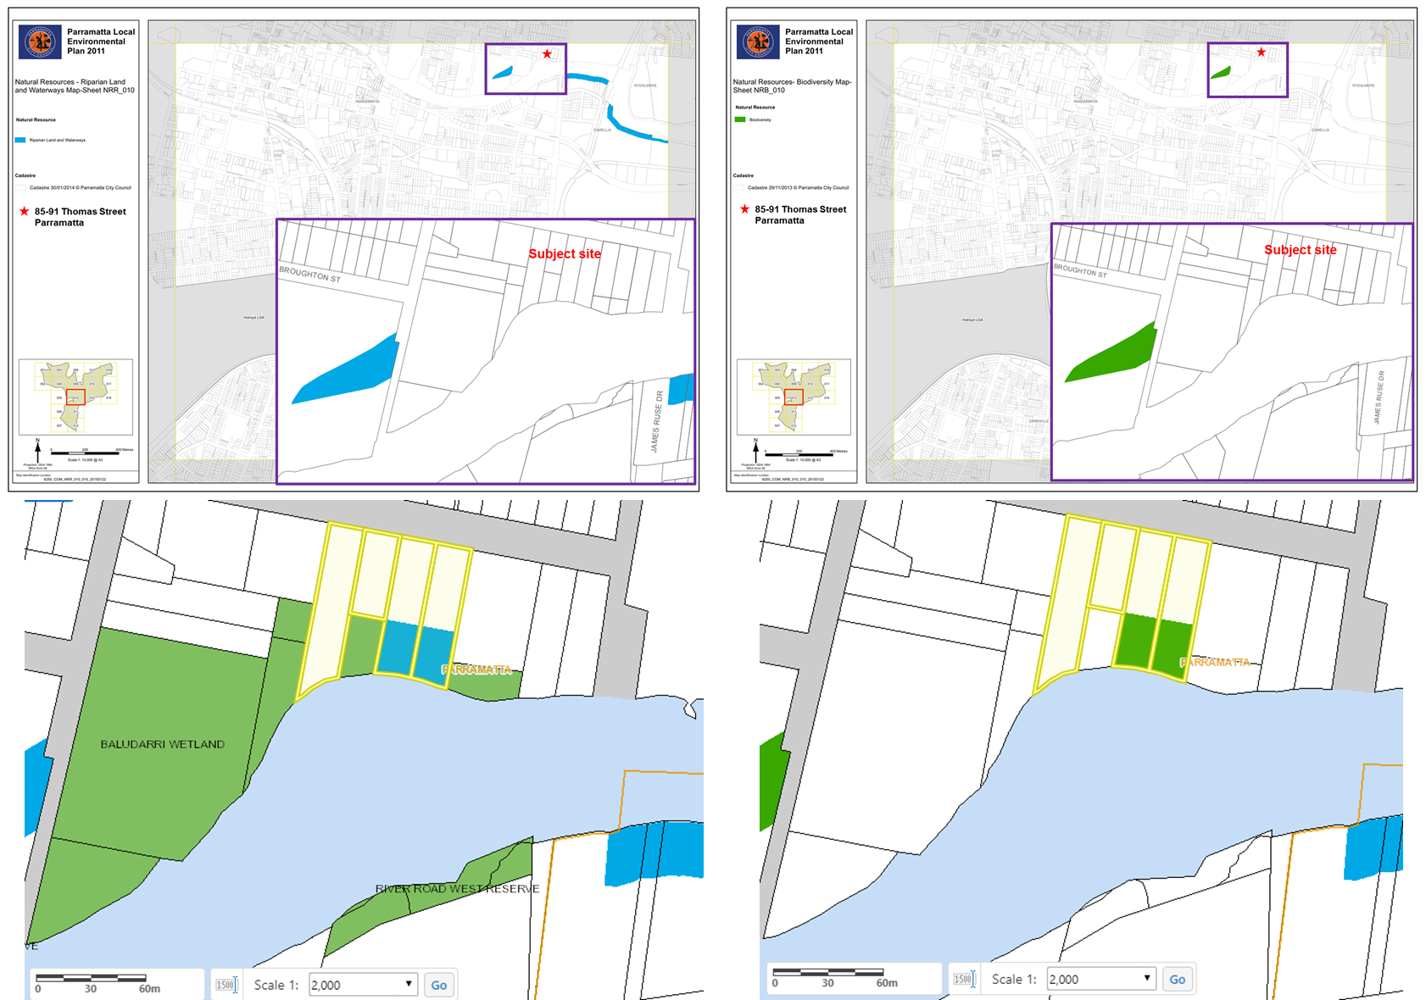
Figure 4 & 5- Subject site and land affectation by Natural Resources – Riparian Lands and Waterways (left) and Biodiviersity (right)

    - Are there any other likely environmental effects as a result of the planning proposal and how are they proposed to be managed?
Heritage
The subject site is affected by the heritage associated with the Parramatta River Wetlands (Item 1 – Schedule 5, Environmental Heritage). This item is located within the undevelopable portion of the site and relates principally to the adjacent Parramatta River. Should the Planning Proposal proceed, land identified as part of heritage will be dedicated to Council ownership.
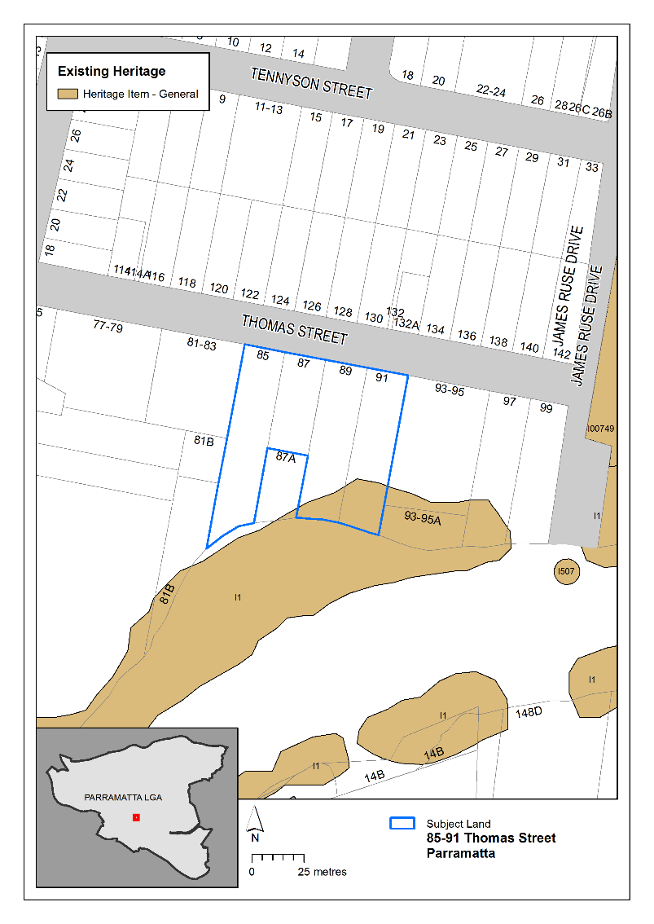
Figure 6 - Heritage affection on subject site by I1 – Parramatta River

The current Planning Proposal proposes that the building envelope is located outside the area affected by Heritage in hope to resolve the heritage and ecological concerns. The Planning Proposal will be referred again to Heritage regarding the heritage and wetland matters as part of a public exhibition associated with a Gateway Determination should the Planning Proposal proceed.

Ecology
Adjacent to the site also includes coastal mangroves and saltmarshes. The Planning Proposal was referred to the former Department of Primary Industries in 2017 seeking comment regarding potential shading impacts to marine vegetation such as the mangroves and saltmarsh to the south of the site. On 15 May 2017, Primary Industries recommended a precautionary approach regarding the ongoing long-term impacts to both the mangroves and saltmarsh. The applicant then provided a revised report which allowed Primary Industries to complete a further assessment. Primary Industry clarified on 9 November 2017 that there “does not see any reason for potential shading issues on mangrove and saltmarsh species to prevent the lodgement of this development, as currently proposed, as a Planning Proposal.
Former concepts for the planning proposal that proposed an increase in GFA for the site raised concerns for Council’s Natural Resources and Open Space team. Caution was raised as an increase in density for the site could set a planning precedent for planning controls to change for the wider precinct which would result cumulative overshadowing impact to the mangroves and salt-marshes. Whilst the Planning Proposal still seeks an increase in height and may increase overshadowing to this ecology, Council officers consider this risk as resolved it satisfies as the planning precedent issue is resolved and an increase in density for this site in isolation (no net-increase in floor-space compared to 2016 controls) is satisfactory.
Flooding
The site is located adjacent to the Parramatta River and includes a steep topography upwards towards Thomas street. The northern part of the site is relatively flat above RL-12. Land towards the south of the site identified for potential land dedication to Council is more susceptive to flooding impacts.
Any potential impacts as a result of development on the site, such as stormwater runoff, will be considered and addressed appropriately at DA stage. This will also include any design detail required to ensure compliance with Council’s water management controls within the Parramatta DCP 2011.
Urban Design
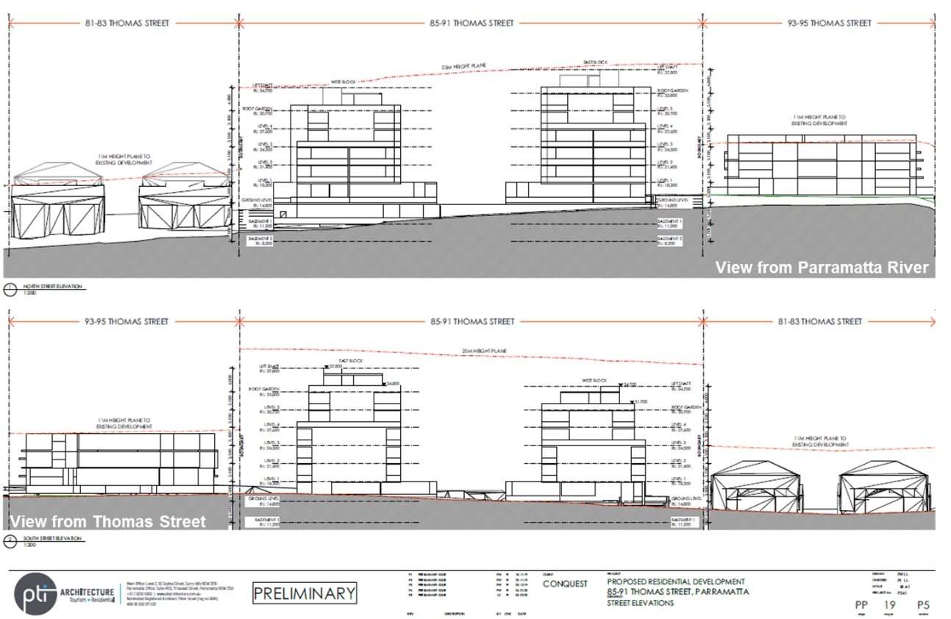
Figure 7- Reference Design for subject site (Source: PTI Architecture)

On 4 February 2020, the applicant provided Council a revised reference design for the Planning Proposal for 85-91 Thomas Street, Parramatta. The applicant’s reference design proposes a 25-metre Maximum Building Height which could accommodate approximately 7 storeys. Council’s Planning and Design units have maintained their recommendation that there is strategic merit in increasing the height to a maximum of 6 storeys to accommodate a similar amount of high-density residential floor-space permissible on the site at lodgement of the Planning Proposal.

Floor Space Ratio

The current scheme submitted by the applicant generates 4,994sqm of GFA for high-density residential purposes. This amount is 953sqm greater than what the current planning controls allow. It is also 63sqm less than the GFA permissible on the site at lodgement in June 2016 where a 0.8:1 FSR control applying to the entire site area (i.e. 5,057sqm of GFA). The Planning Proposal aims to amend the maximum Building Height and Floor Space Ratio controls to accommodate no-net increase in high-density residential GFA compared to what was previously permissible under Development Application controls on the site at lodgement of the application. Therefore the dwelling yield, while increasing compared to the current controls, will be the same when compared to the planning controls which applied to the site when the Planning Proposal was lodged with Council.

Building Height

The existing building height control allows for high-density residential development of maximum 3-storeys to be accommodated on the site. The adjoining property at 93-95 Thomas Street demonstrates a recent example of what could be developed under the existing planning controls (DA/630/2012). This neighbouring development is able to comfortably achieve the current maximum FSR within the existing building height as it does not need to respond to the topographic constraints and foreshore building line evident on the subject site, which significantly reduces the developable area of the subject site.

The applicant’s Planning Proposal proposes a 25-metre Maximum Building Height which could accommodate approximately 7 storeys. This height limit is considered excessive given the reference design proposes only 6-storey development on the site. Figure 8 and 9 show that a 22m height plan can accommodate the reference design and reasonably achieve a 6-storey development despite the sloping topography. The 6-storey height is supportable with a 4-storey street wall, additional setbacks for 5th & 6th storeys and separation to adjacent development. The reference design accommodates a 3.3m variation between the proposed ground level at Thomas Street (RL 14.5m) and lower ground level at the rear (RL 11.2m). This maintains a 4-storey form at street level and no more than 6-storeys across the site.

Part 3.1 of the Parramatta DCP 2011 provides a preliminary building envelope guide recommends a 20m height limit for 6-storey residential flat buildings, with this assessment taking into consideration the sloping topography of the site to inform an appropriate building height. The applicant has revised their concept design to a building envelope of maximum 6-storeys, however still proposes a maximum building height of 25 metres. This height limit is considered onerous for a 6-storey development on the site, with a revised increase in height up to 22m for approximately 6 storeys for the following reasons:
  - It represents a 10% variation from 20m in the DCP Preliminary Building Envelope recommendation for 6-storey residential flat buildings,
  - It is double the existing HOB control which would allow the currently permissible high-density residential floorspace on the southern half of the site (located in the foreshore building line) to be massed in a taller built form,
  - It accommodates the 3.3m variation between the proposed ground level at Thomas Street (RL 14.5m) and lower ground level at the rear (RL 11.2m). This maintains a 4-storey form at street level and no more than 6-storeys across the site.
  - Rooftop gardens above a 6th storey to inform a 25 metres HOB are not certain and could lead to a 7th storey being accommodated.

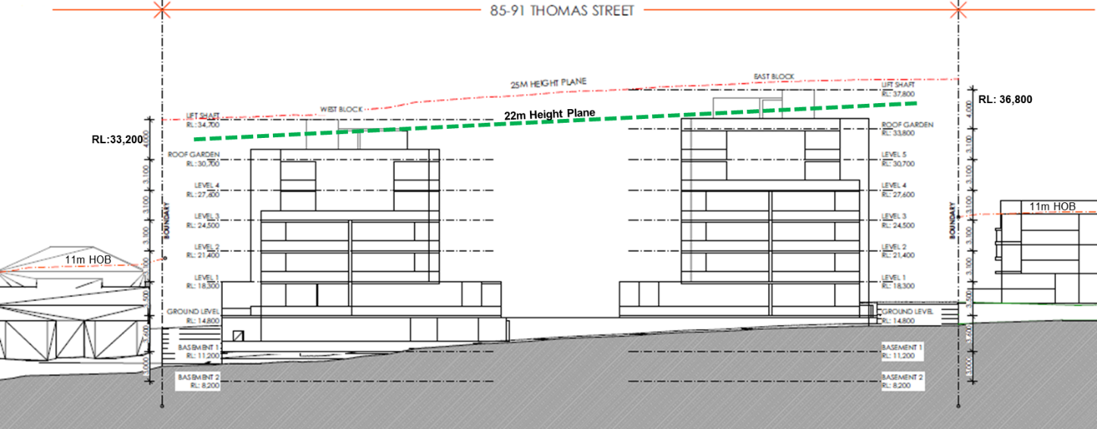
Figure 8 – Section facing north from Parramatta River with adjacent properties (Source: PTI Architecture)
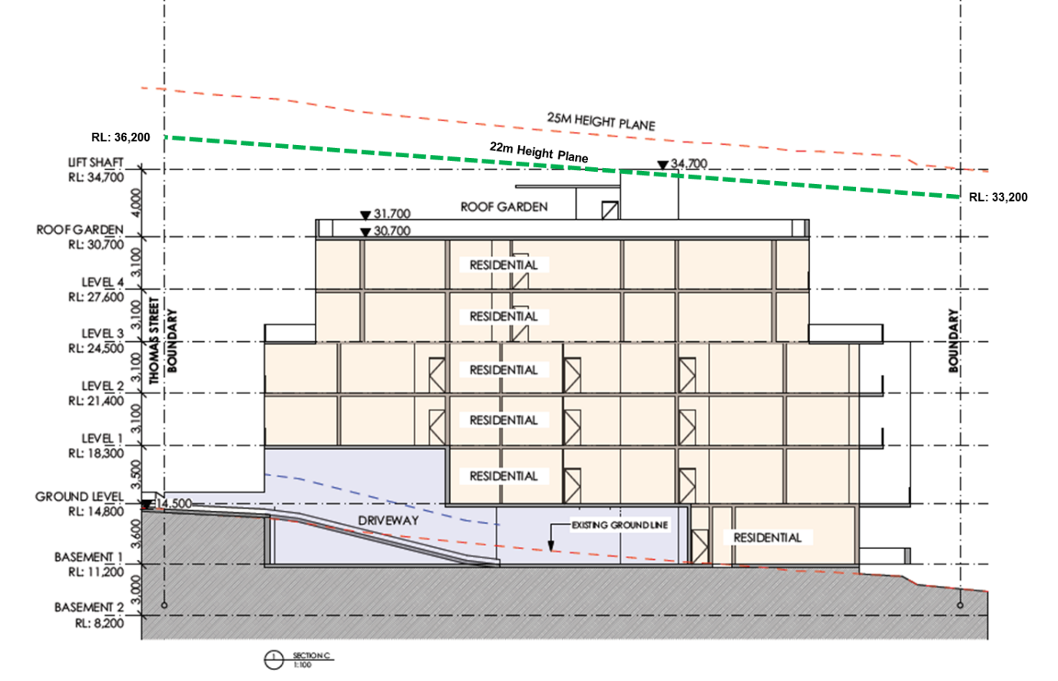
Figure 9– Section facing east from adjacent townhouse development (Source: PTI Architecture)

Building Separation & Setbacks

Given the potential increase in building height on the subject site, it is important to carefully manage privacy and amenity impacts on the adjacent properties, particularly the adjacent townhouse development located near the boundary at 81-83 Thomas Street and single dwelling houses on the northern side of Thomas Street.

The Apartment Design Guide and SEPP 65 set the minimum standards for building separation and setbacks for any residential flat building development on the site. Currently, the ADG would require a minimum of 9 metres separation between habitable and non-habitable rooms for buildings up to 4 storeys, and minimum of 12 metres for buildings 5 to 8 storeys. The reference design included as part of this planning proposal seeks to provide:
- Street setback of 6 metres up to 4-storeys, 9 metre setback up to 6-storeys, 10 metre for rooftop
- Side setback of 10 metres up to 4-storeys, 12 metre setback up to 6-storeys, 13 metre for rooftop.
- Minimum 12 metre building separation between west and east block apartment buildings,
- Rear setback of 3 metres to edge of developable portion of site and foreshore building line,

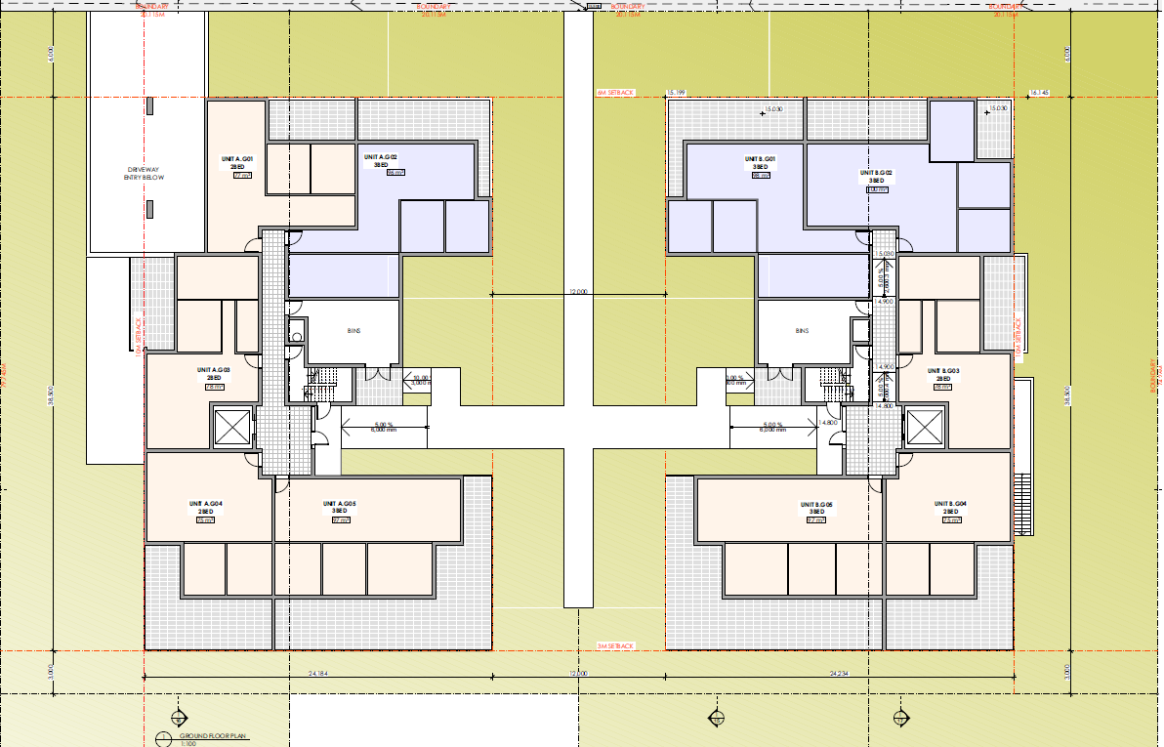
Figure 10 – Ground Floor Setbacks for developable site area
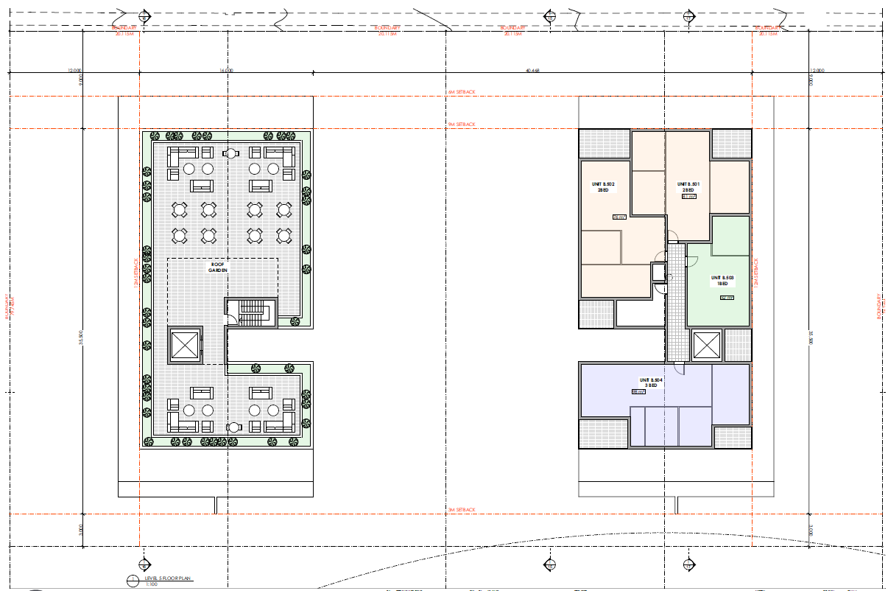
Figure 11 – Level 5 and 6 Setbacks developable site area
Deep soil areas and tree plantings within 6 metres of the front and side property boundary will be required to further improve the relationship of the site with neighbouring buildings. This hopes to provide a satisfactory interface with adjacent properties and satisfy concerns relating to privacy and amenity. The setbacks proposed under the reference design are supportable by Council officers in addressing the privacy and amenity of neighbouring and future residents. These setback standards will be reinforced by a proposed site-specific DCP.
Future development on the site proposes to amalgamate the 4 lots subject to the Planning Proposal. Amalgamation of the sites is supported if the proposed development addresses the scale of adjacent development (such as the townhouses, existing apartment building and single dwellings) and rhythm of the surrounding subdivision pattern with adequate building separation and setbacks exceeding the Apartment Design Guide requirements . Previous concept designs demonstrated a singular elongated row building, driveway and basement entry outside the building envelope, building within the foreshore building line, no additional setback for floors above 4-storeys, are not supported due to their adverse impacts on neighbouring properties and surrounding streetscape. The modulation of the façade will be supported by landscaping and further design detail at Development Application stage as guided by the site specific DCP. The current concept design includes two apartment blocks spaced evenly across the 4 lots, with additional front and side setbacks for Level 5 and 6 which provide a transitioning scale and separation to the scale of development and is supportable (see Figure 11).
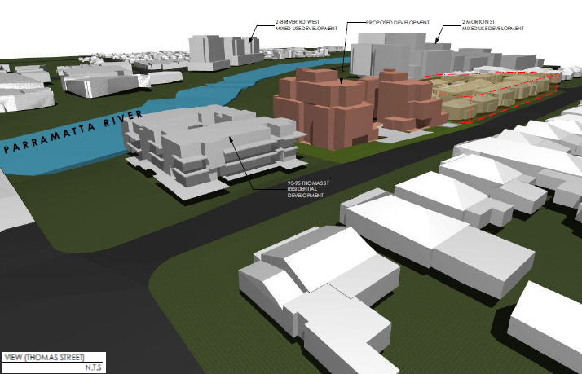
Figure 11 – Indicative streetscape
    - How has the planning proposal adequately addressed any social and economic effects?
Council and State Government does not identify Thomas Street, and this part of Parramatta (Short’s Corner) as a growth precinct in accordance with Council’s Draft Local Housing Strategy and GSC’s Draft Place-based Infrastructure Compact. No major rezonings are required in this precinct for housing are likely to be made by City of Parramatta to meet the 5 year and 20 year housing targets. Any new proposals for new precincts must be justified under strategic planning objectives other than housing supply.

The Planning Proposal, draft site-specific Development Control Plan and draft Planning Agreement are informed by 2,496sqm of land dedication proposed which relates to the southern part of the site. Some of this land is identified for biodiversity and riparian lands (1,200sqm) and some for local open space (1,296sqm). Land dedication is supported in principle as part of the planning proposa.

Section D – State and Commonwealth Interests
    - Is there adequate public infrastructure for the planning proposal?
On 7 November 2019, the GSC released the draft Place-based Infrastructure Compact (PIC) for the Greater Parramatta and Olympic Peninsula (GPOP) area. Specifically, the PIC outlines a draft-sequencing plan to support GPOP and growth in certain precincts in order to inform capital investment plans and budget processes of NSW Government agencies. The site is situated within the “Shorts Corner” precinct, which is not included as part of Phase 1 or Phase 2 areas and therefore not identified for growth within the GPOP (see page 45 and 47, PIC). This makes an increase in density above the 0.8:1 FSR across the whole site area difficult to support.

The Planning Proposal is being facilitated so the applicant may accommodate the 4,655sqm of intended GFA for the subject site as intended by the R4 zoning of the site. It decants the GFA from land zoned R4 outside the Foreshore Building Line, Natural Resources area and Land Reserved for Acquisition which makes most of the undevelopable land. Should the applicant intend to dedicate the 2,496sqm of undevelopable land to Council, the Floor Space Ratio for the site would increase from 0.8:1 to 1.2:1 FSR. Council officers support the massing of GFA within a 6-storey dual building envelope, requiring an increase in maximum HOB from 11m to 22m. Floor Space Ratio and Maximum Building Heights will be removed from the undevelopable portion of the land which is proposed for RE1 zoning.

There is likely to be a modest land value uplift given that no additional floor-space is proposed as part of the application. A base-value for the land is also difficult to identify given the 1,296sqm portion at No.85 Thomas Street was zoned R4 at lodgement, and RE1 at pre-Gateway reporting stage.

The VPA also provides a no-cost pathway for Council to become owners of the RE1 land. This removes the acquisition burden and potentially greater cost for Council to acquire the land from the landowner. It is uncertain whether that this offer is consistent with Council’s Planning Agreement’s Policy which seeks to capture 50% of the value uplift for sites outside of the Parramatta CBD. The dedication of the RE1 land is considered a supportable public benefit that outweighs the cost of assessing and completing a peer-review process of a valuation report for a planning proposal that does not propose additional high-density residential floorspace. The land value uplift process is considered an unreasonable expectation for this application and the VPA offer is acceptable in principle only.

    - What are the views of State and Commonwealth public authorities consulted in accordance with the gateway determination?
Consultation with the State and Commonwealth public authorities will be undertaken once the gateway determination has been issued.

PART 4 – MAPPING
This section contains the mapping for this planning proposal in accordance with the DP&E’s guidelines on LEPs and Planning Proposals.

Existing controls
This section illustrates the current PLEP 2011 controls which apply to the site. 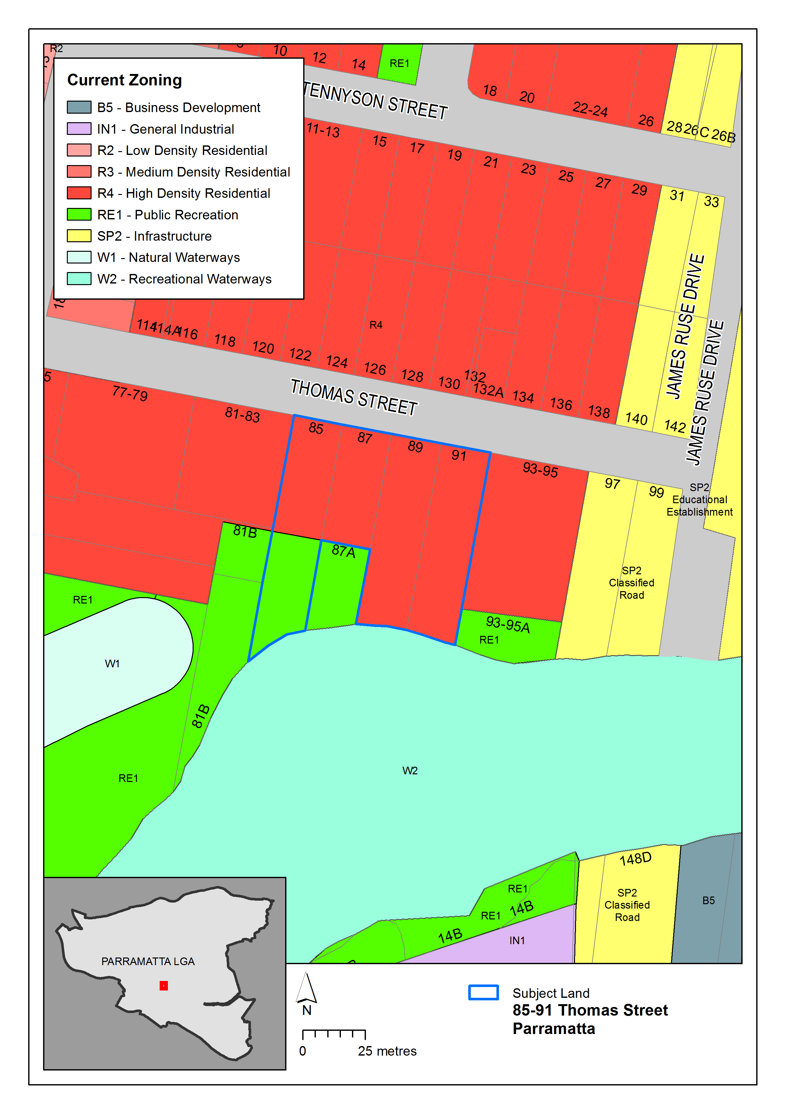
Figure 12 – Existing zoning extracted from Parramatta LEP 2011 Land Zoning Map

Figure 12 illustrates the existing R4 – High Density Residential, part RE1 Public Recreation

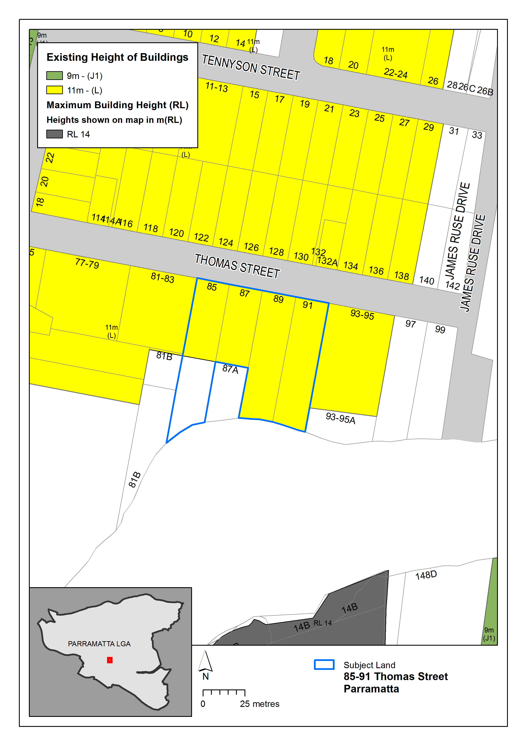
Figure 13 – Existing building heights extracted from the Parramatta LEP 2011 Height of Buildings Map

Figure 13 illustrates the existing 11 metre maximum building height.

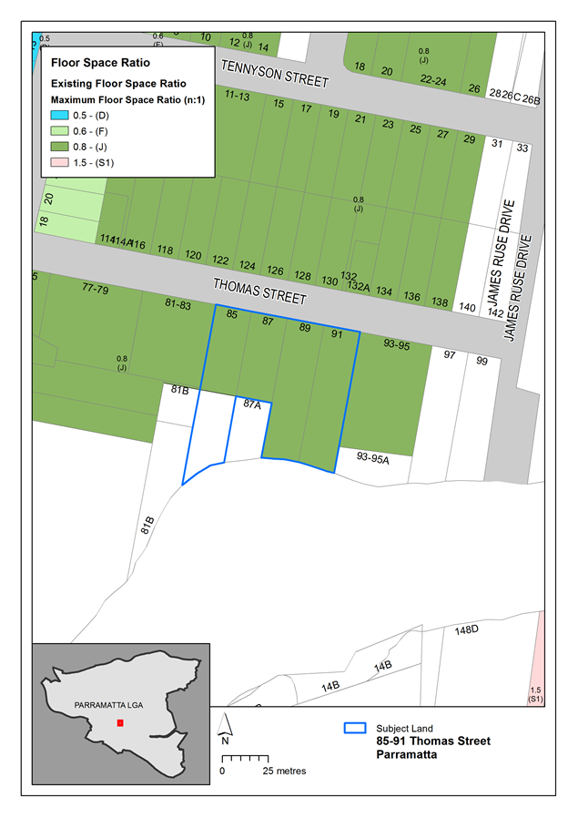
Figure 14 – Existing floor space ratio extracted from the Parramatta LEP 2011 Floor Space Ratio Map

Figure 14 illustrates the existing 0.8:1 Floor Space Ratio.

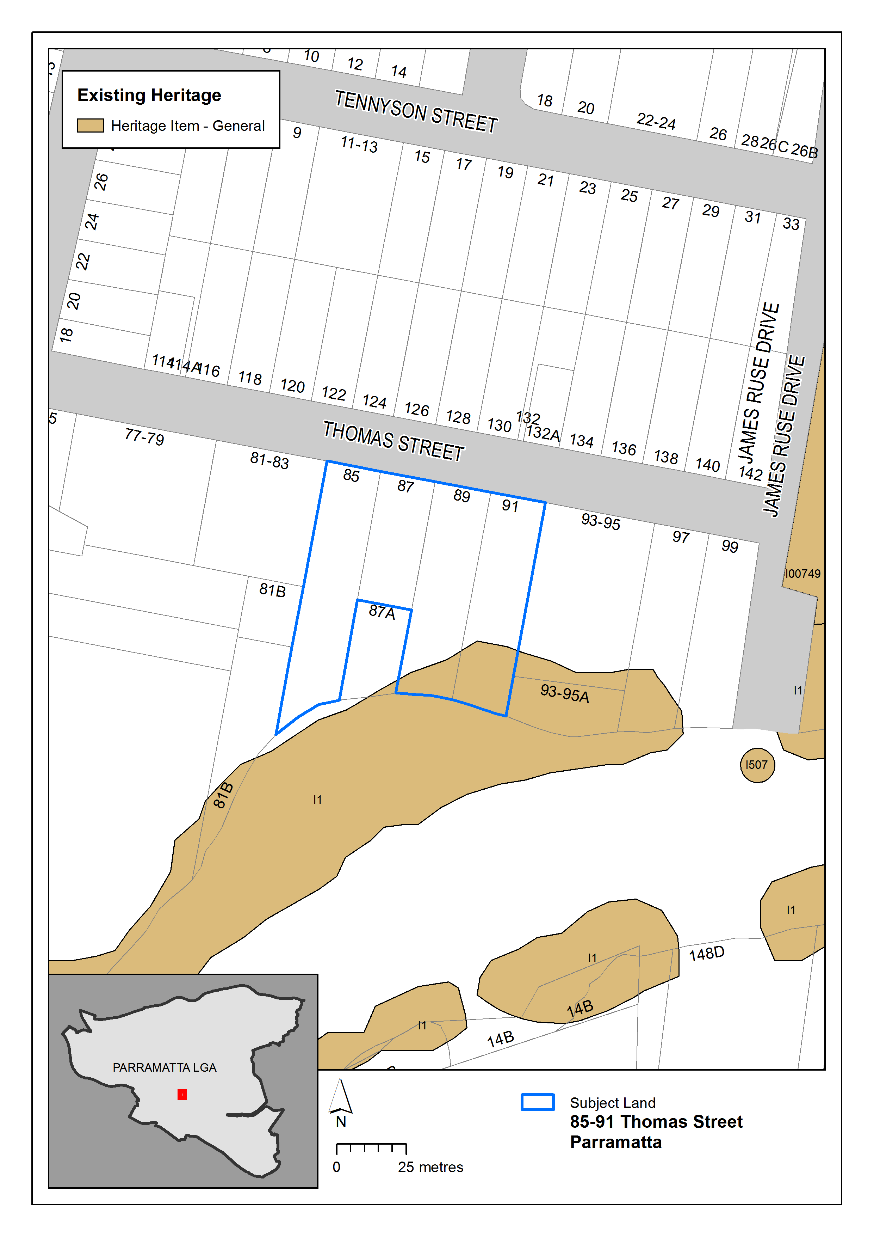
Figure 15 – Existing heritage items extracted from the Parramatta LEP 2011 Heritage Map

Figure 15 above illustrates Item 1 – Parramatta River Wetlands of local significance which impact the site.
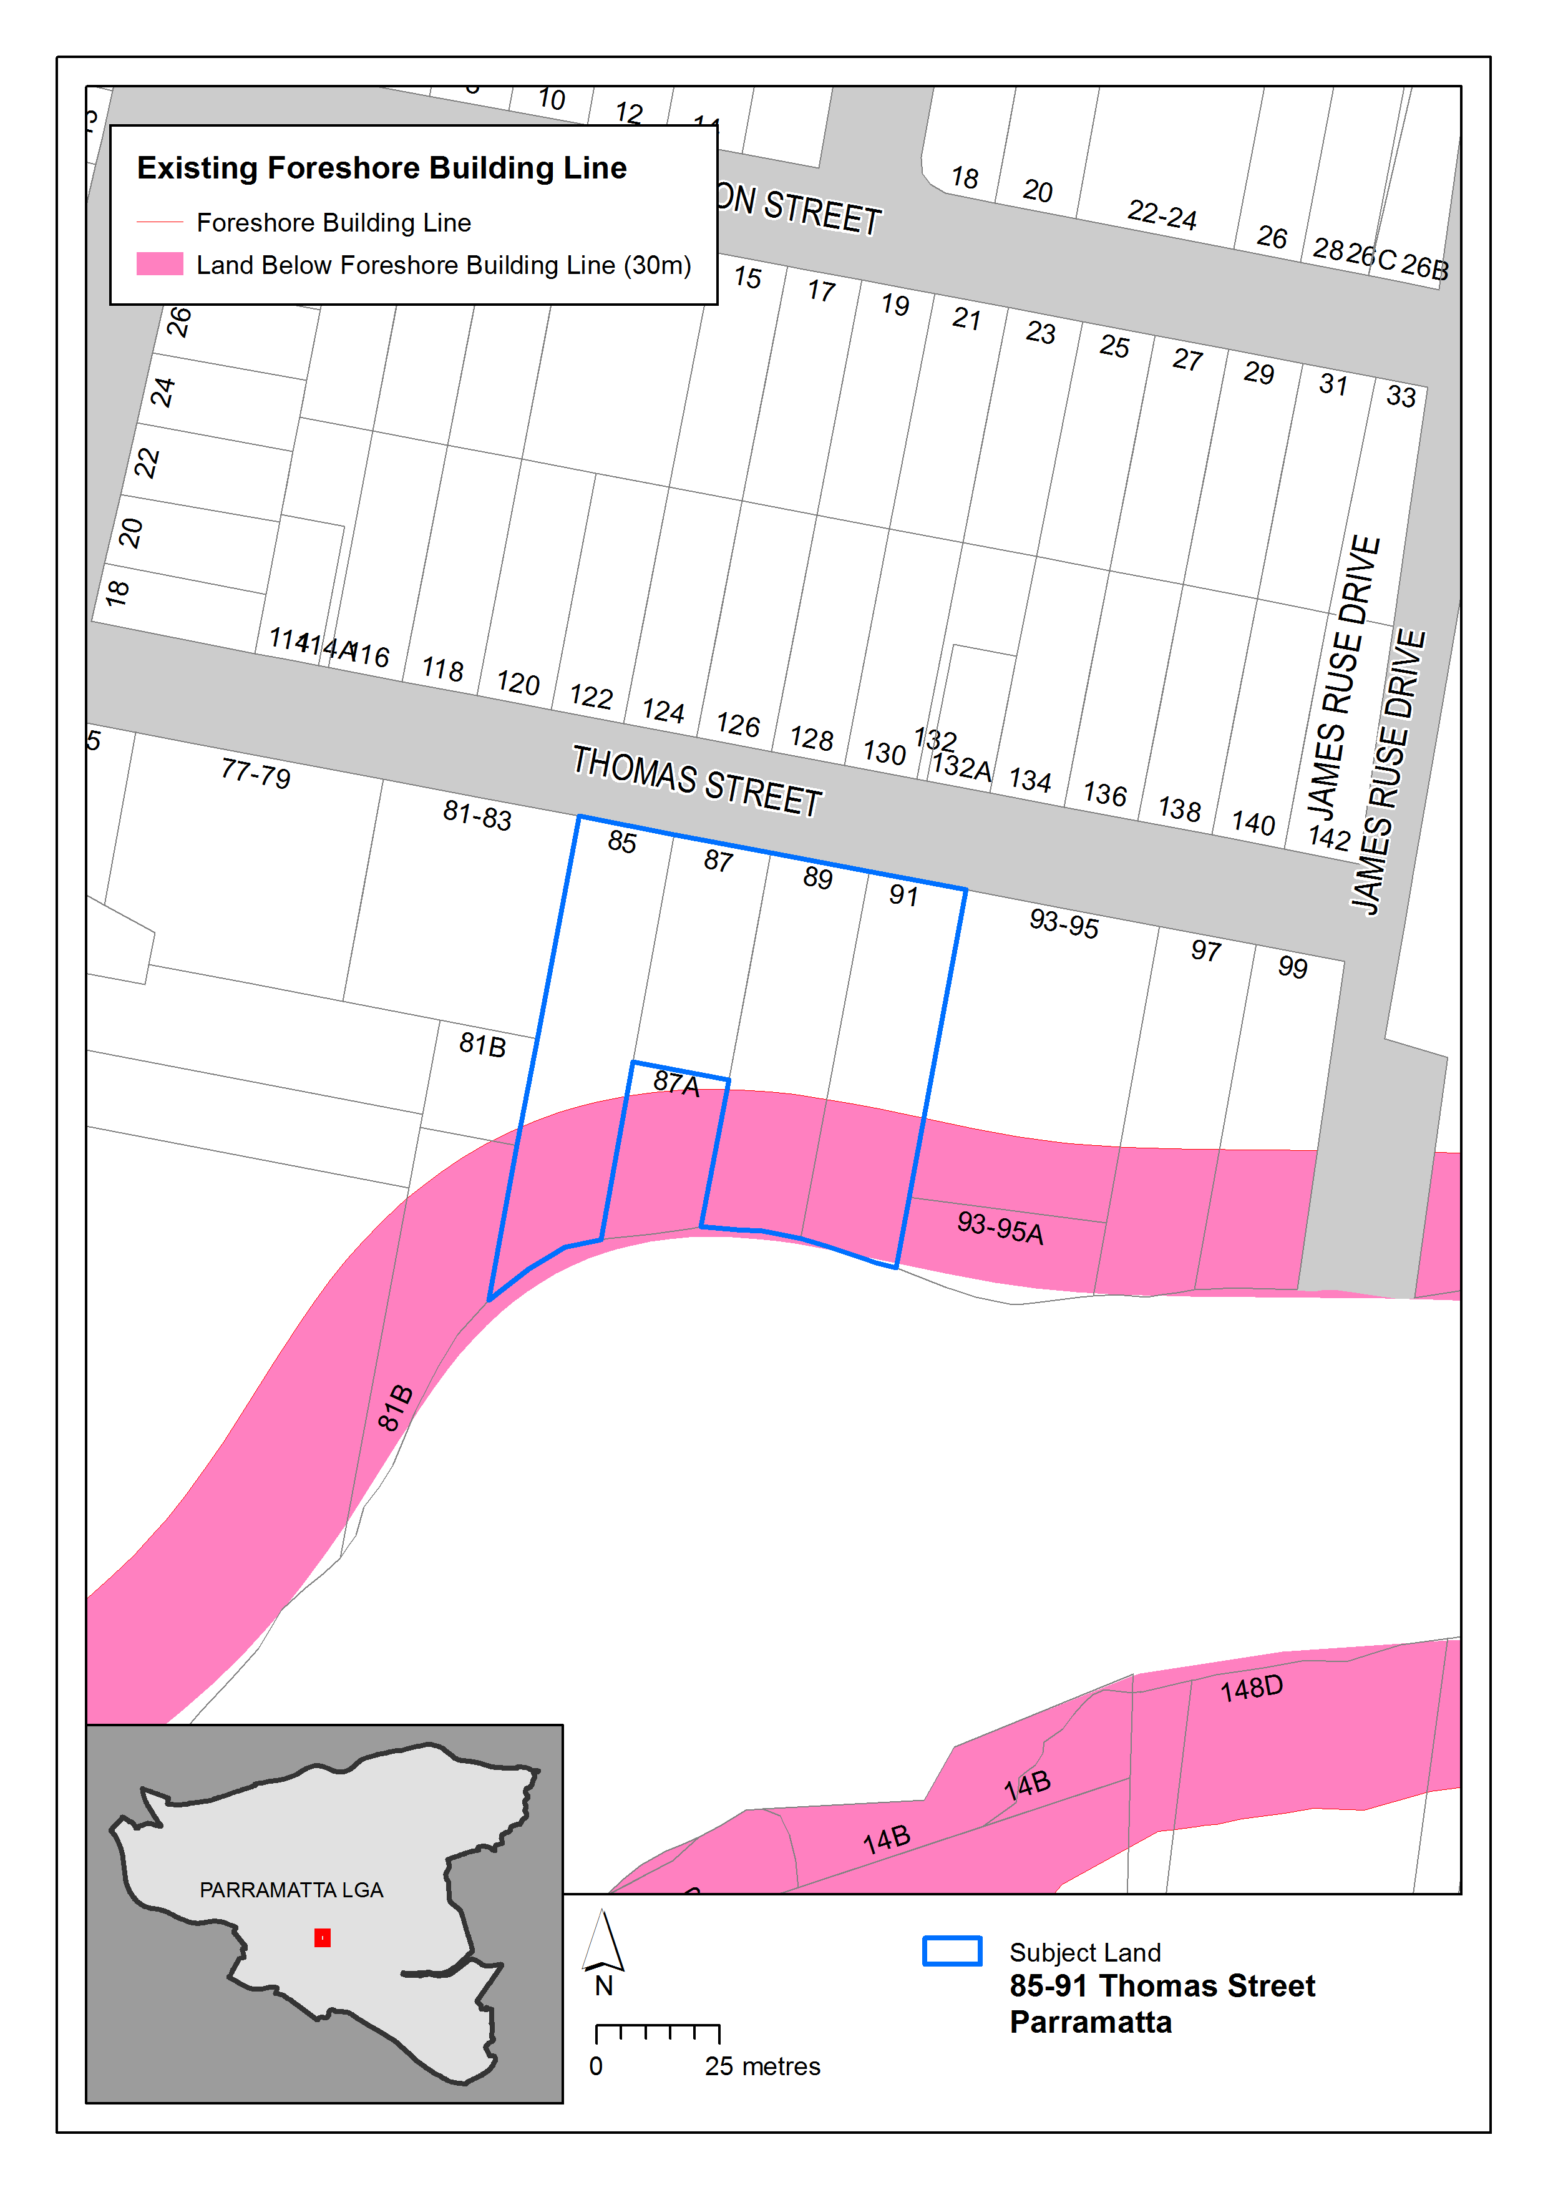
Figure 16 – Existing Foreshore Building Line in Parramatta LEP 2011 Map

Figure 16 above illustrates the extent of the Foreshore Building Line map
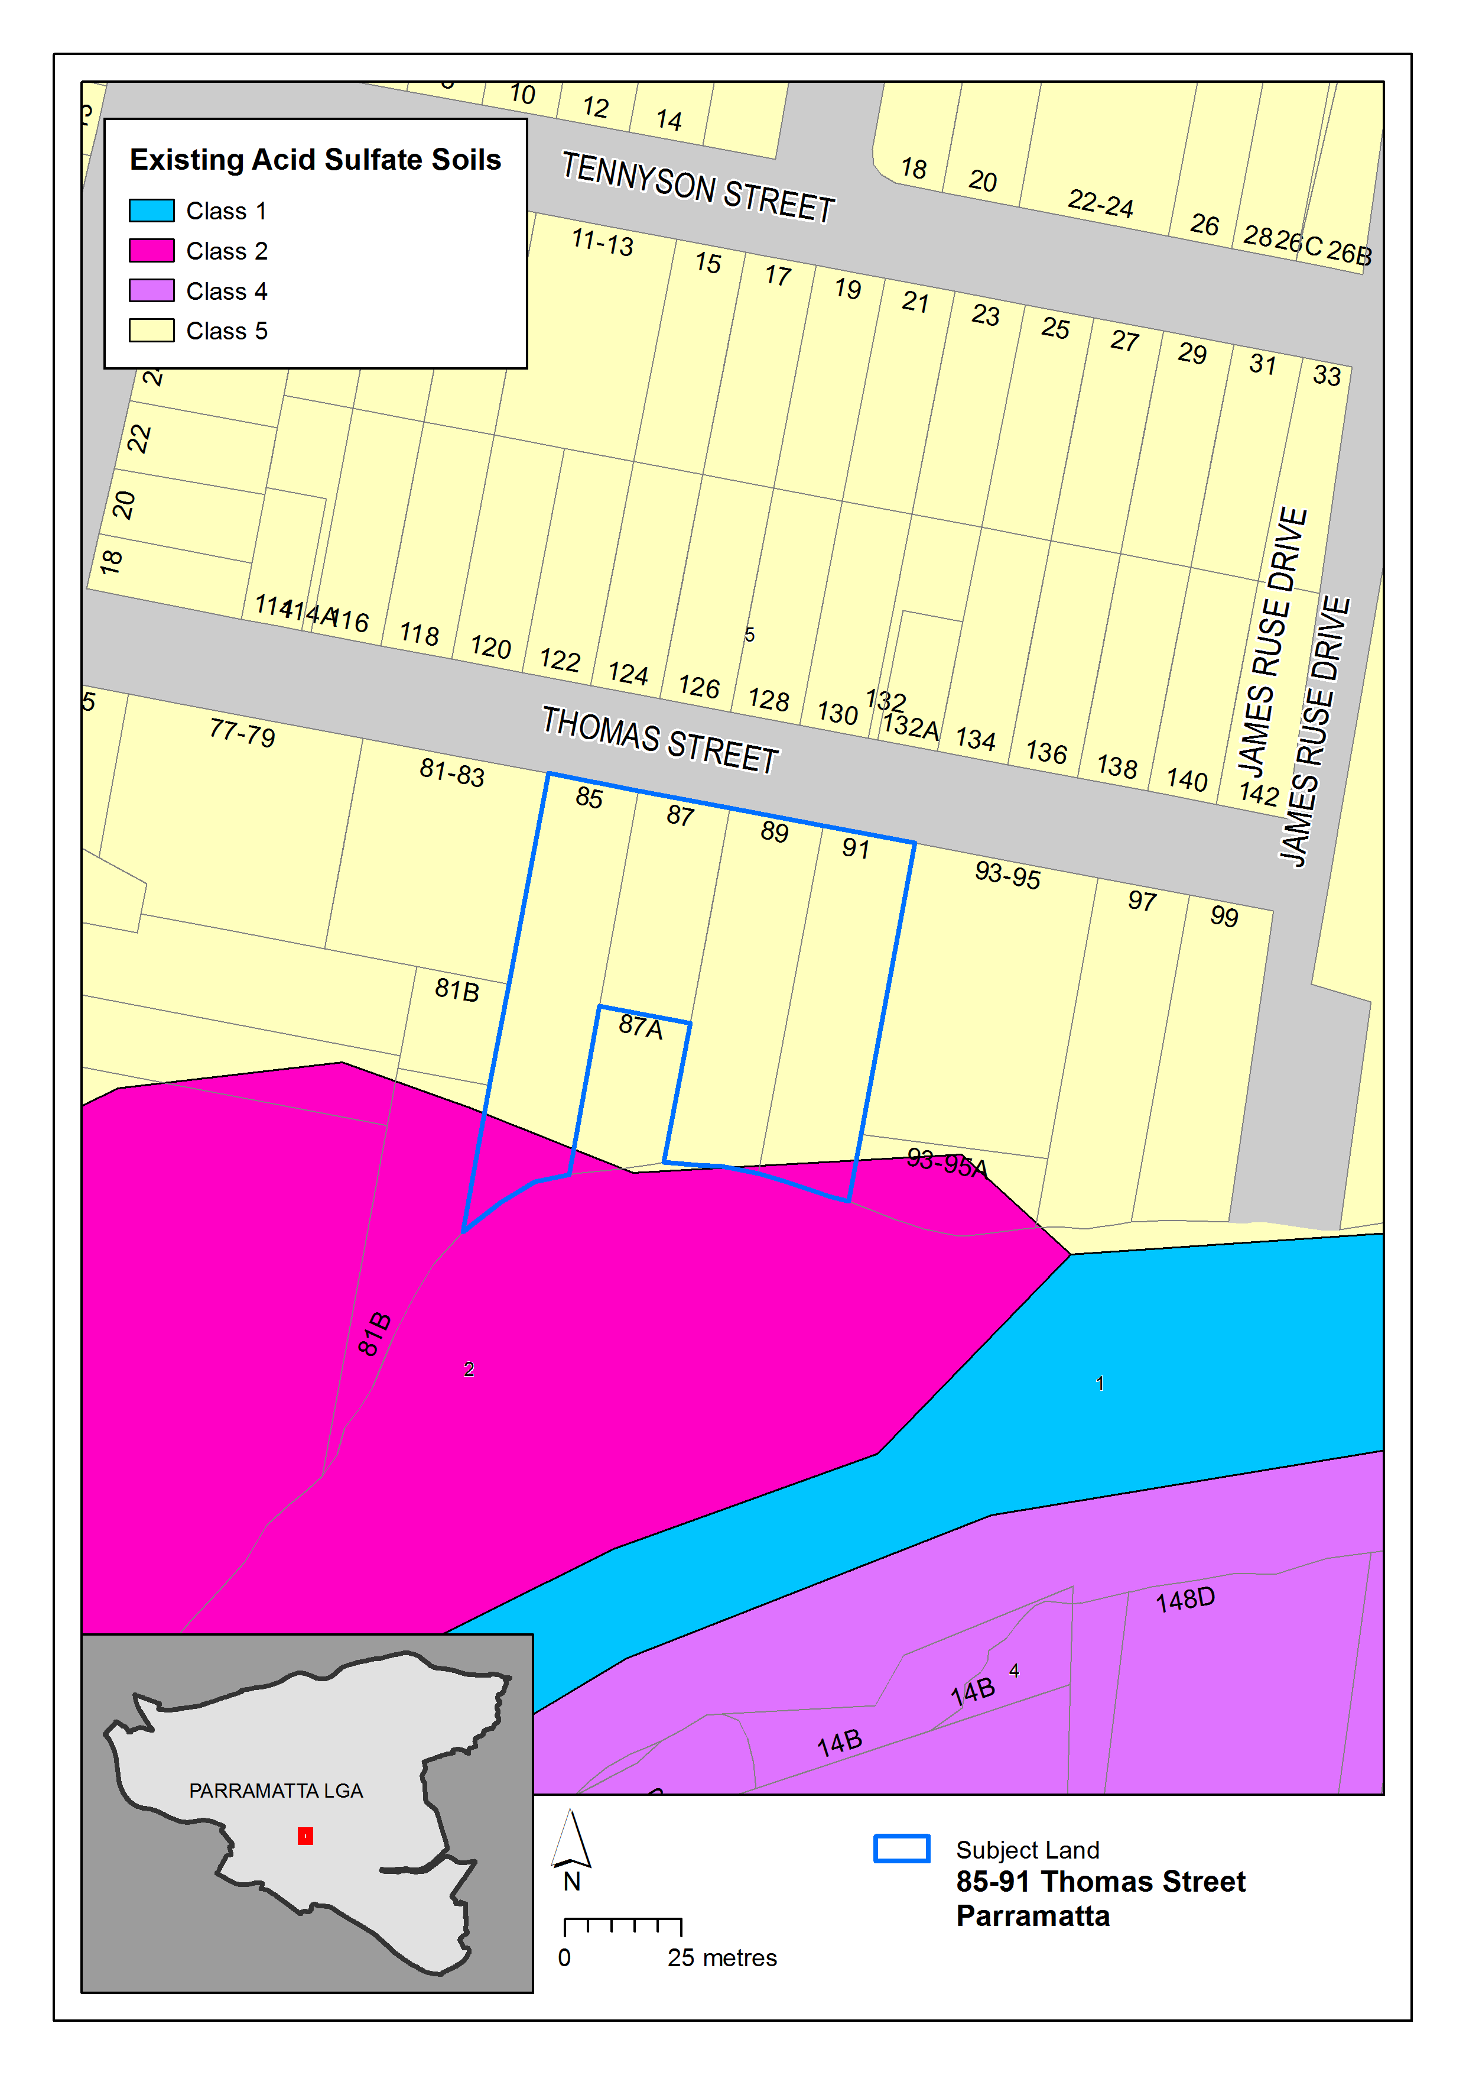
Figure 17 – Existing Acid Sulfate Soils in Parramatta LEP 2011 Map

Figure 17 above illustrates the extent of the Acid Sulfate Soils on the subject site. The developable portion is subject to Class 5, with some land to the south Class 2.

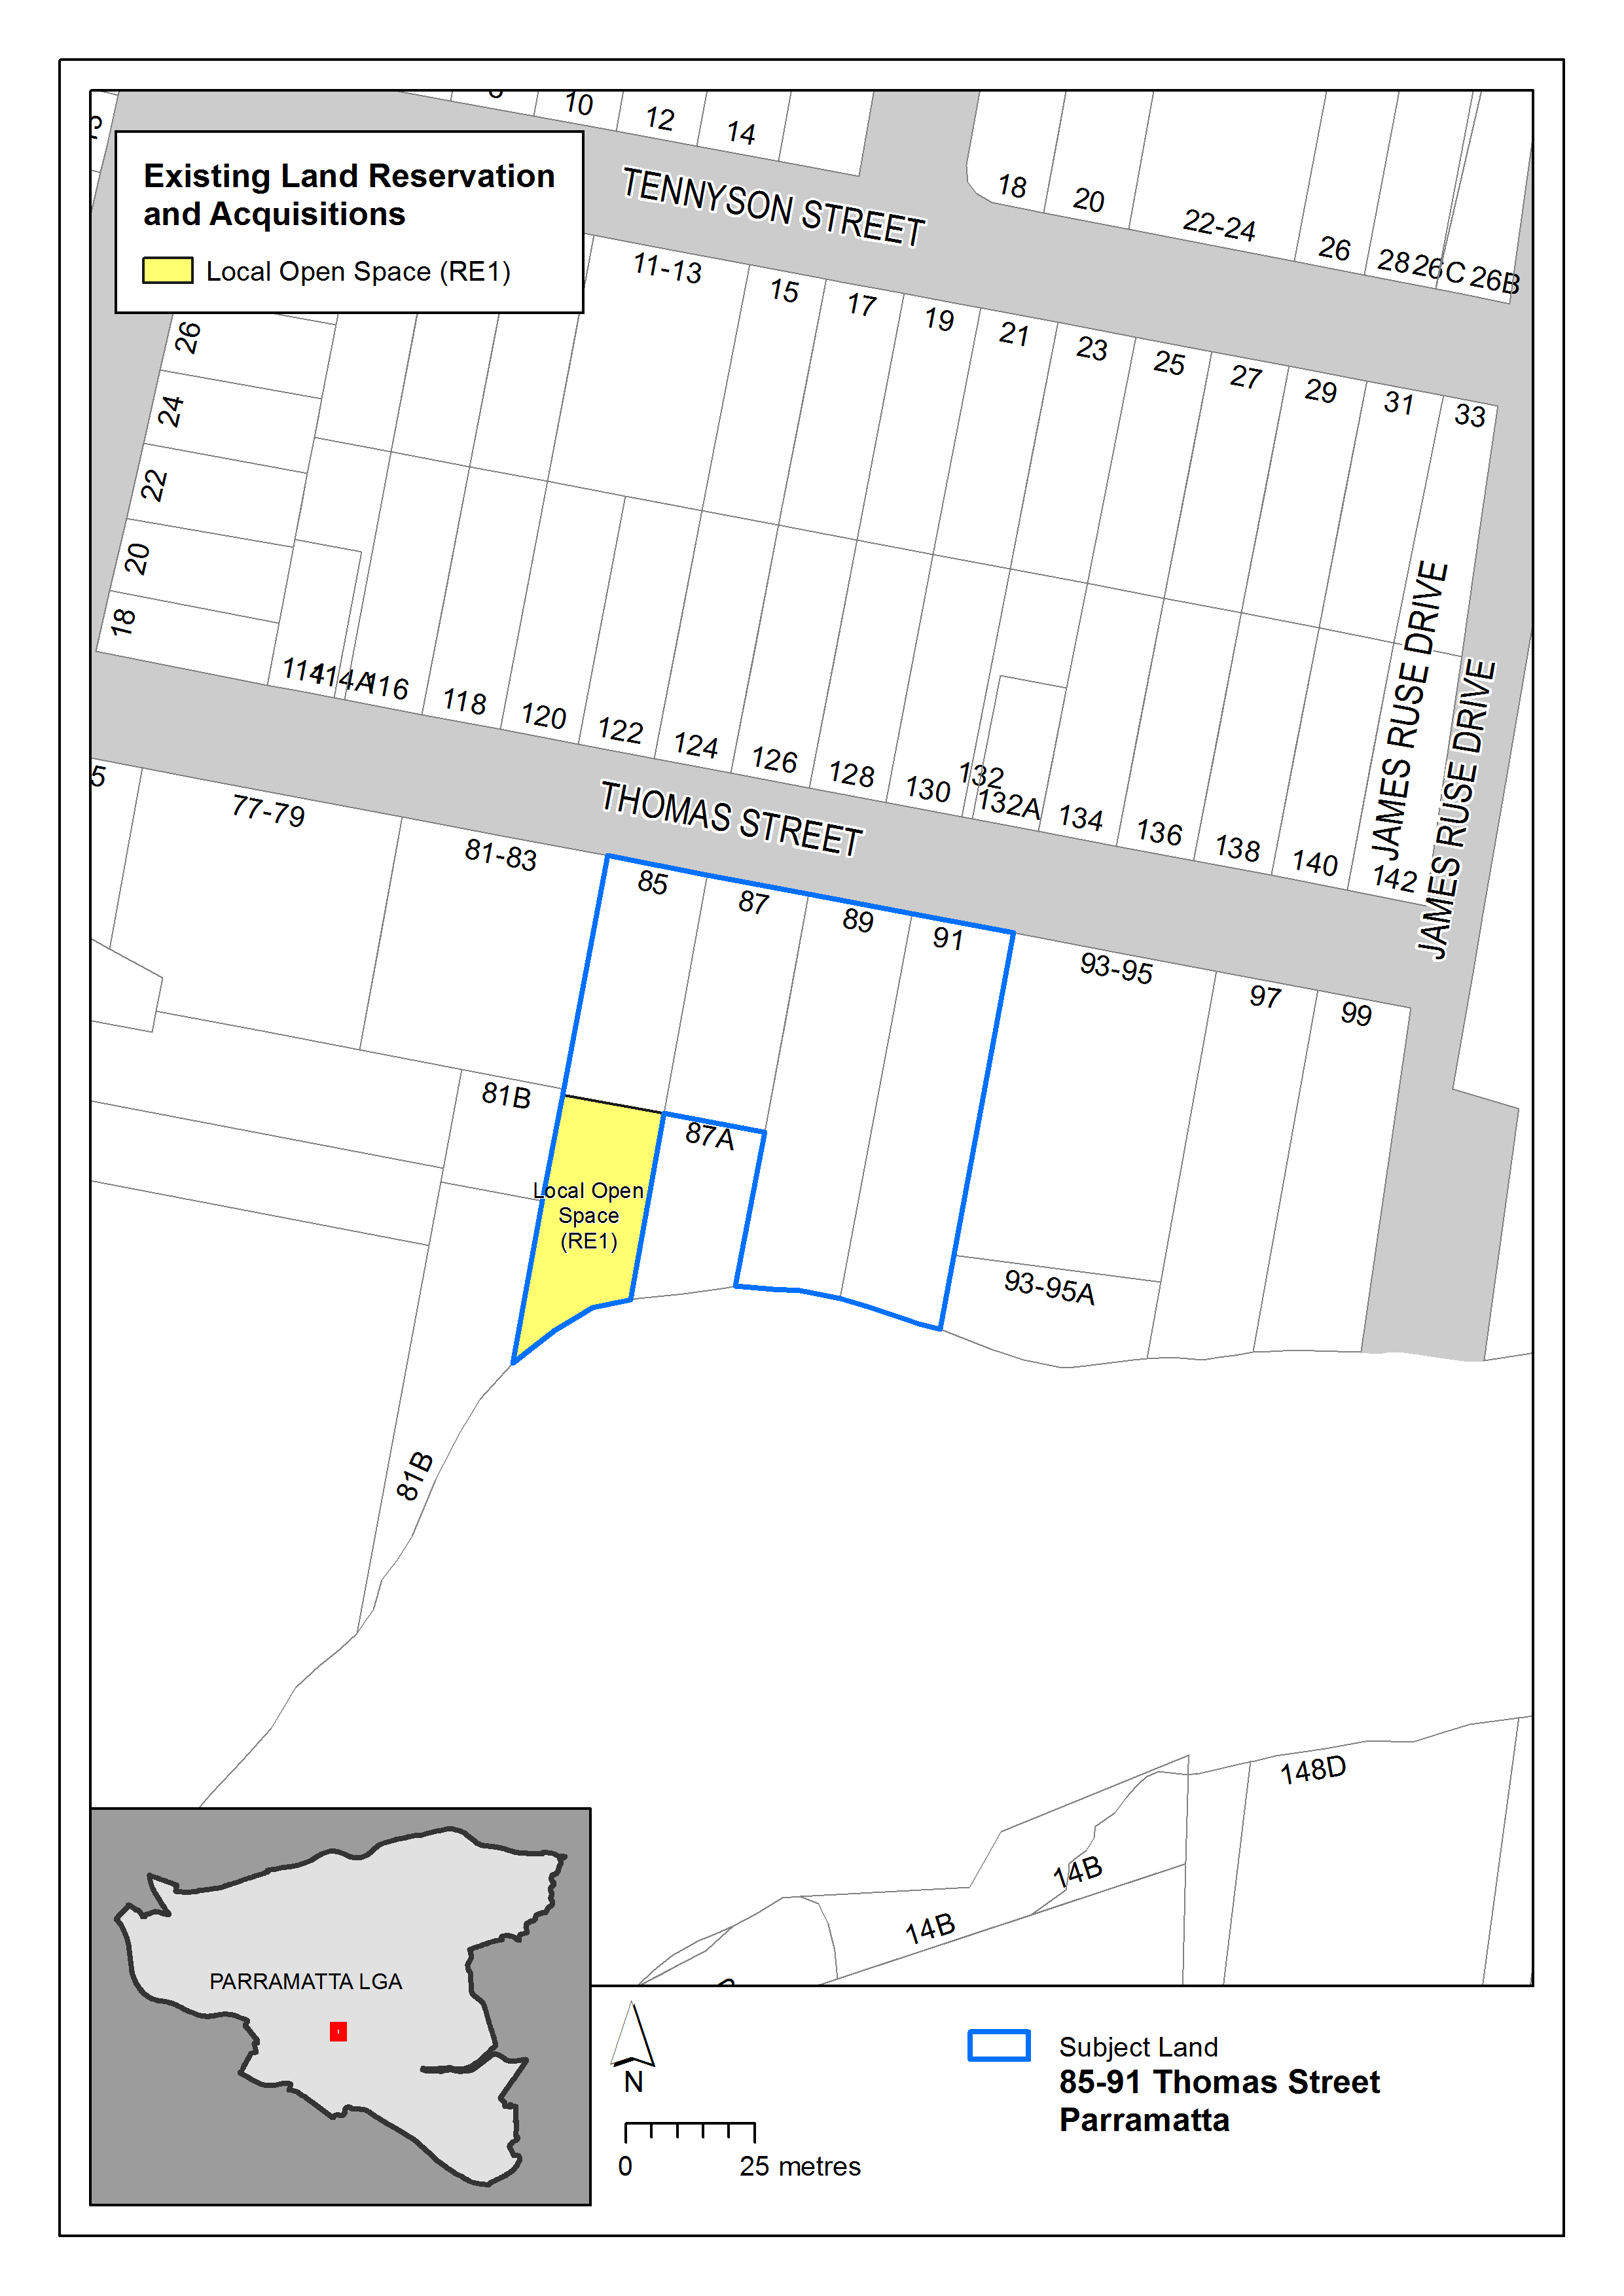
Figure 18 – Existing Land Reserved for Acquisition in Parramatta LEP 2011 Map

Figure 18 above illustrates the extent of the Land Reserved for Acquisition map showing the affectation on No.85 Thomas Street.
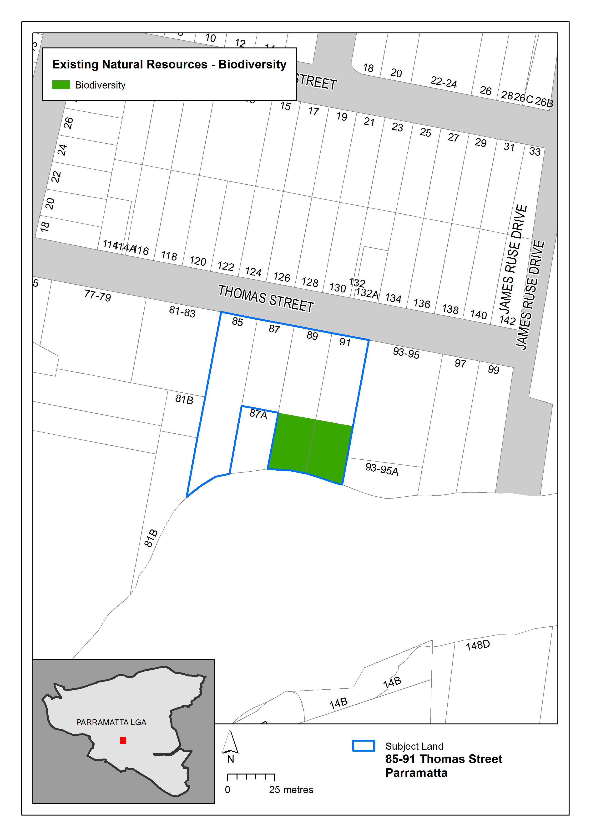
Figure 19 – Existing Natural Resources - Biodiversity in Parramatta LEP 2011 Map

Figure 19 above illustrates the extent of the Natural Resources -Biodiversity map showing the affectation on No.89-91 Thomas Street within the undevelopable portion of the site.
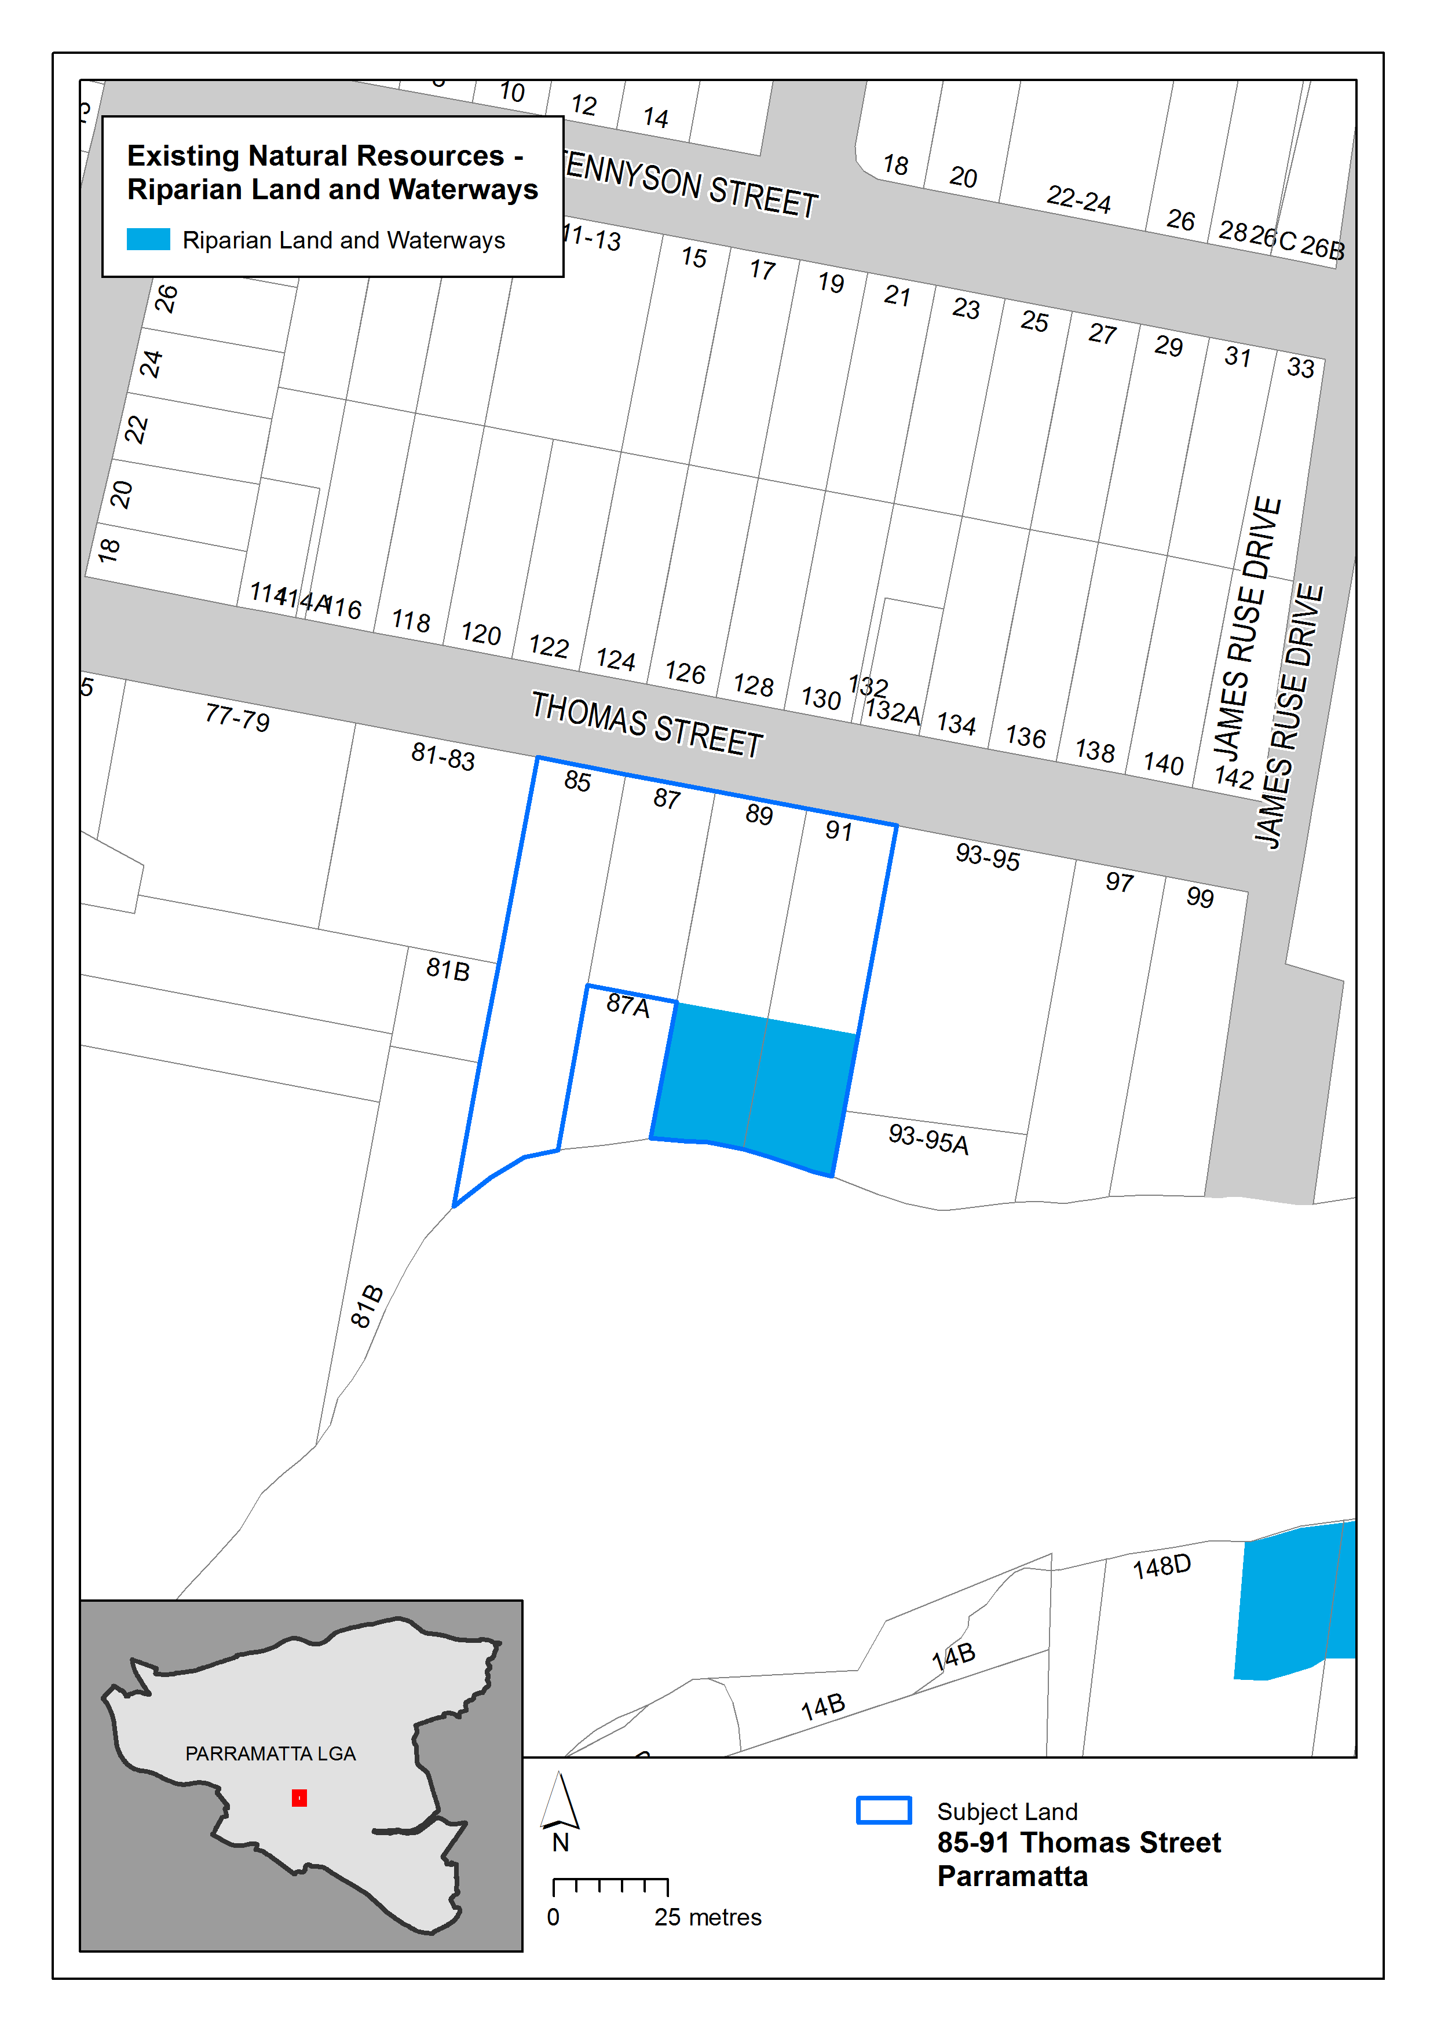
Figure 20 – Existing Natural Resources – Riparian Land and Waterways in Parramatta LEP 2011 Map

Figure 20 above illustrates the extent of the Natural Resources – Riparian Land and Waterways map showing the affectation on No.89-91 Thomas Street.
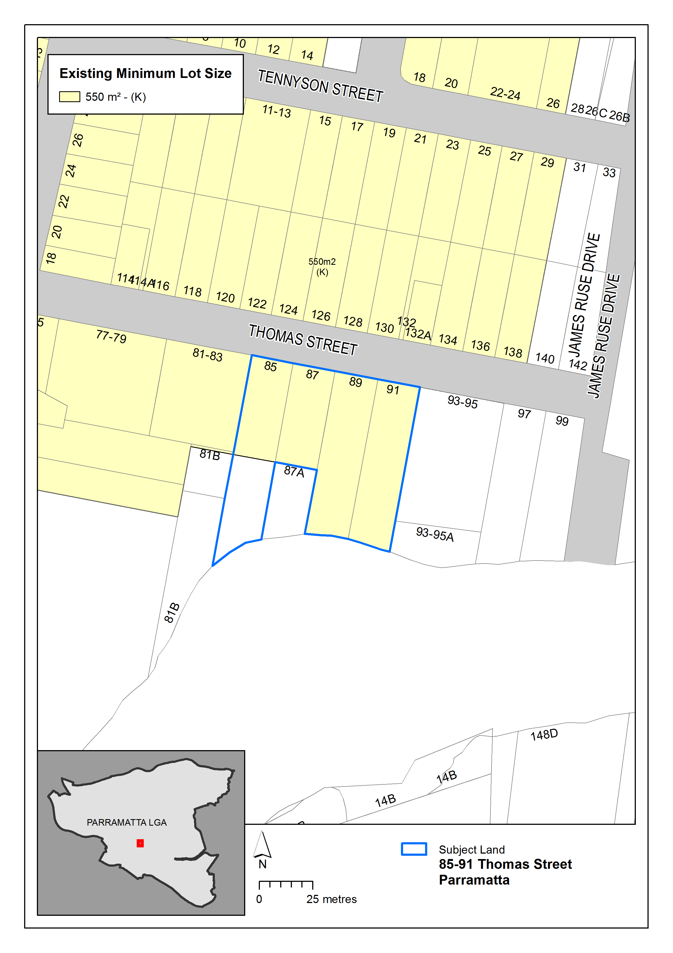
Figure 21 – Existing Minimum Lot Size in Parramatta LEP 2011 Map

Figure 21 above illustrates Minimum Lot Size of 550sqm on the subject site.

Proposed controls
The figures in this section illustrate the proposed change to maximum building height for the subject site. No other changes are proposed as part of the Planning Proposal.
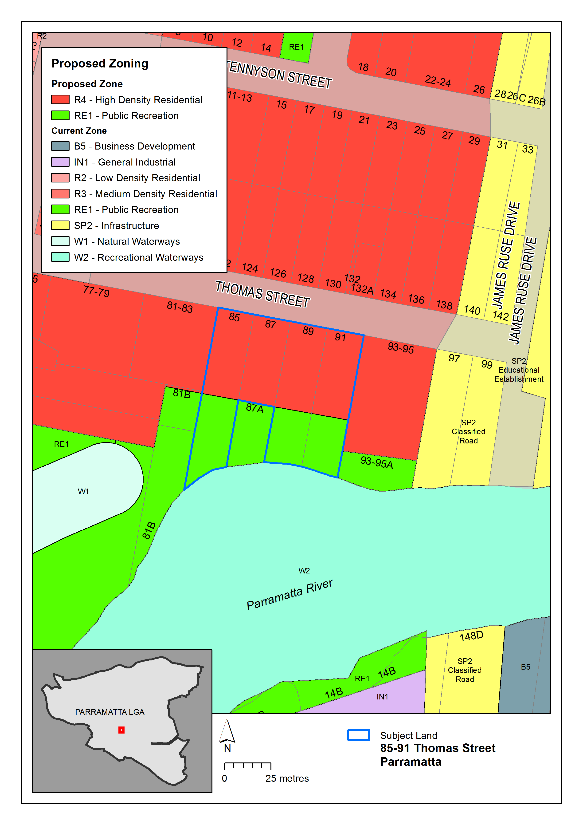
Figure 22 – Proposed amendment to the Parramatta LEP 2011 Land Use Zoning Map

Figure 22 above illustrates proposed boundary changes to land use zoning to reflect the developable portion of the site and proposed land dedication.
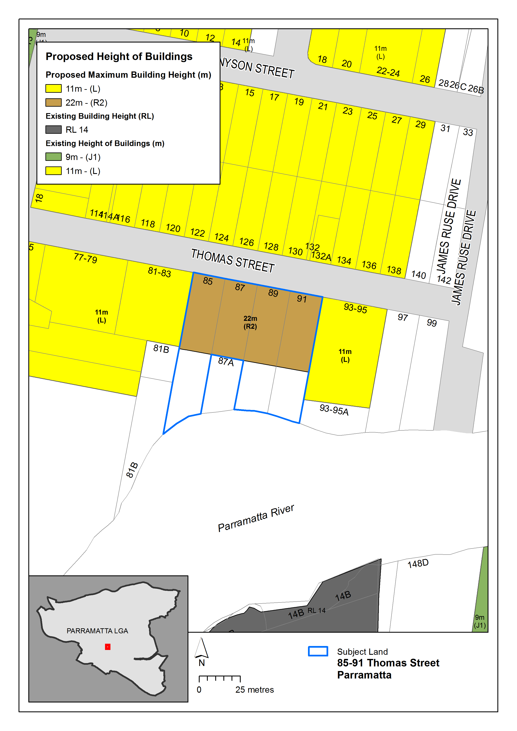
Figure 23 – Proposed Maximum Building Height in Parramatta LEP 2011 Map
Figure 23 above illustrates the extent of the proposed maximum building height up to 22 metres. It also shows the removal of HOB control for the undevelopable land.
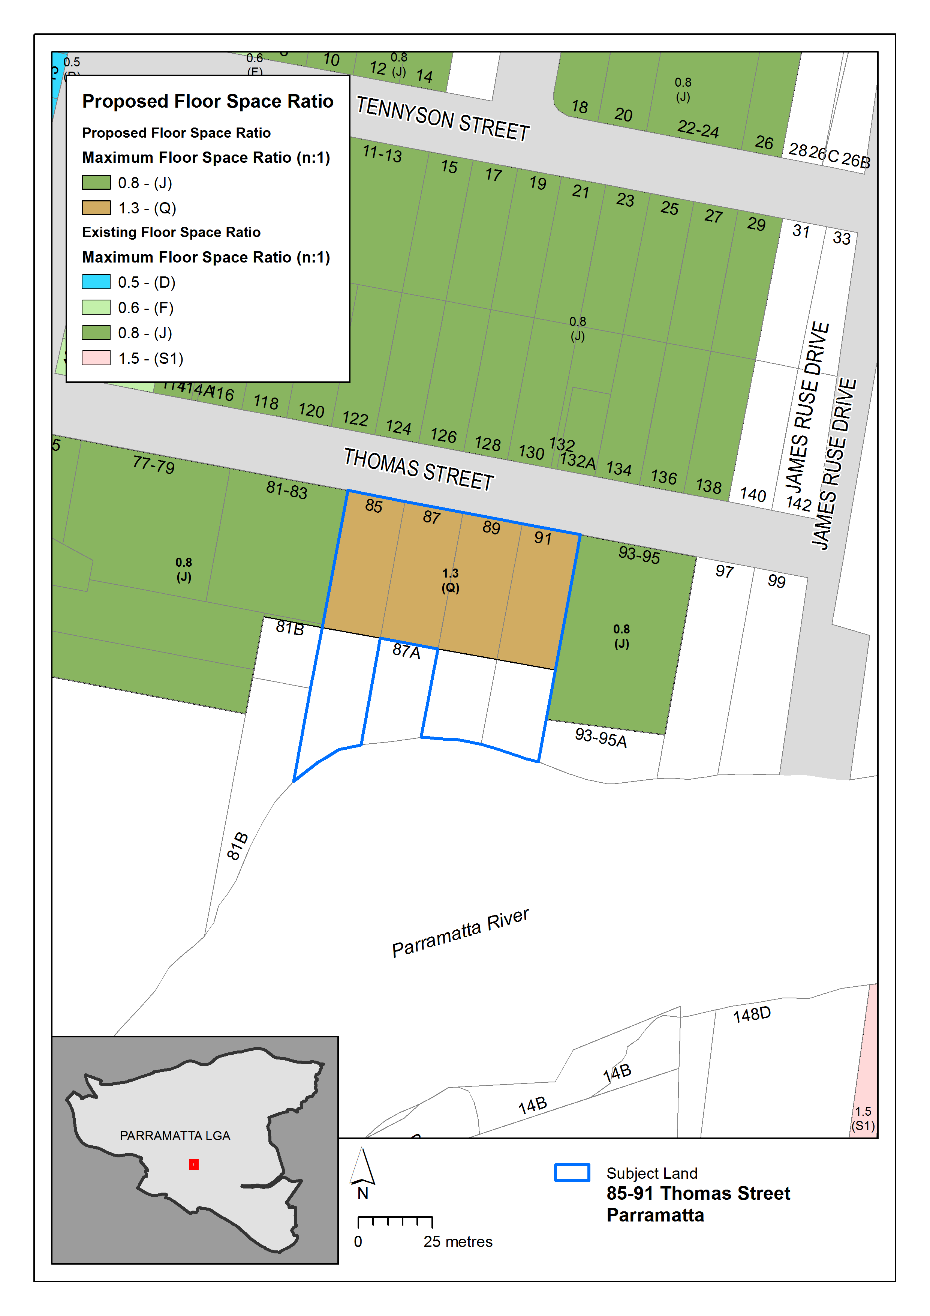
Figure 24 – Proposed Floor Space Ratio in Parramatta LEP 2011 Map
Figure 24 above illustrates the extent of the proposed floor space ratio of 1.3:1. It also shows the removal of FSR control for the undevelopable land.

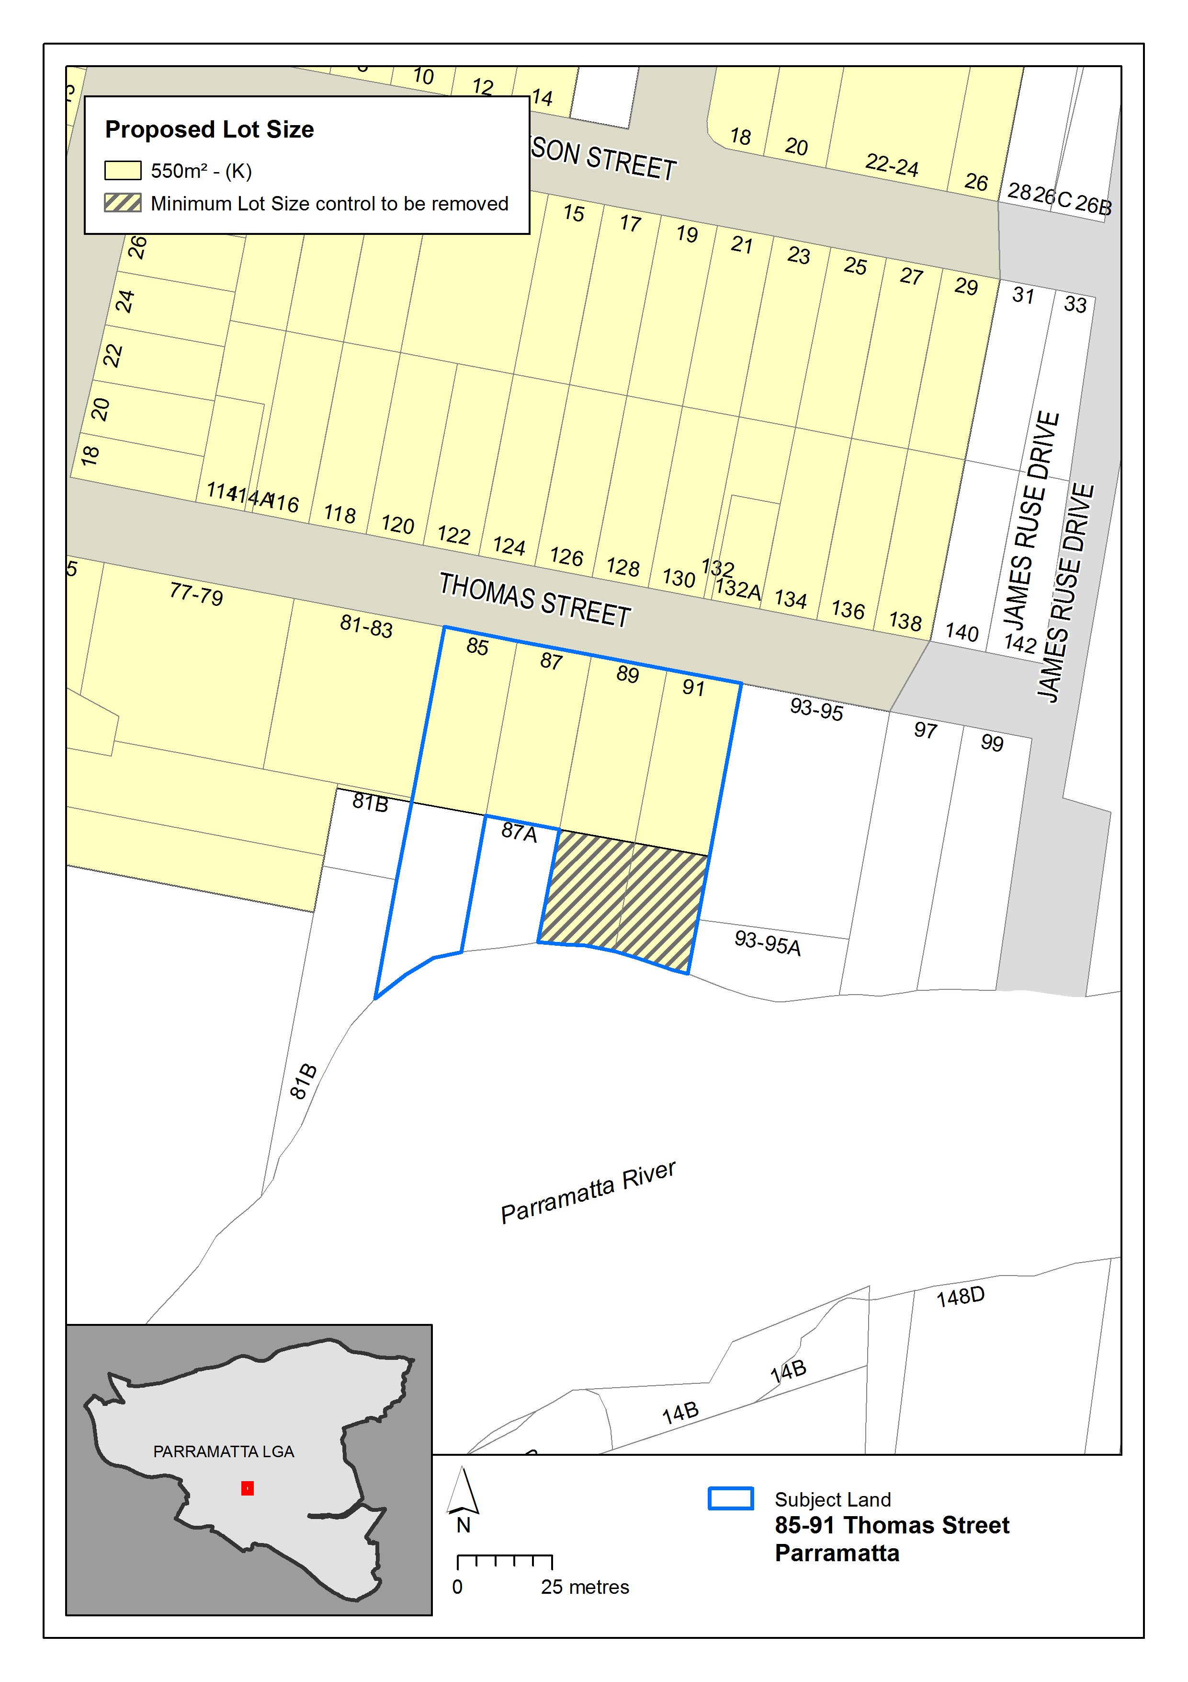
Figure 25: Proposed Minimum Lot Size Map in Parramatta LEP 2011 Map

Figure 25 illustrates the removal of the minimum lot size control from the undevelopable land proposed to be dedicated as part of the Planning Proposal.
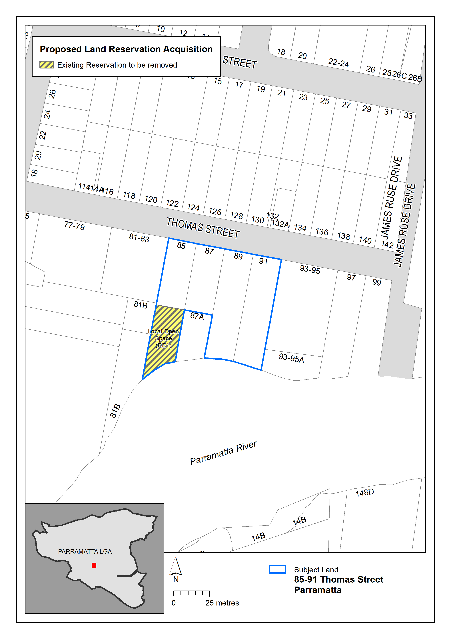
Figure 26: Proposed Land Reserved for Acquisition Map in Parramatta LEP 2011 Map
Figure 26 illustrates the extent of the proposed land reserved for acquisition map. It shows the removal of the land acquisition should the land be dedication for local open space.

PART 5 – COMMUNITY CONSULTATION
The planning proposal (as revised to comply with the Gateway determination) is to be publicly available for community consultation.

Public exhibition is likely to include:
- newspaper advertisement;
- display on the Council’s web-site; and
- written notification to adjoining landowners.

The gateway determination will specify the level of public consultation that must be undertaken in relation to the planning proposal including those with government agencies.

Consistent with sections 3.34(4) and 3.34(8) of the EP&A Act 1979, where community consultation is required, an instrument cannot be made unless the community has been given an opportunity to make submissions and the submissions have been considered.

PART 6 – PROJECT TIMELINE
Once the planning proposal has been referred to the Minister for review of the Gateway Determination and received a Gateway determination, the anticipated project timeline will be further refined, including at each major milestone throughout the planning proposal’s process.

Table 7 below outlines the anticipated timeframe for the completion of the planning proposal.

Table 7 – Anticipated timeframe to planning proposal process
MILESTONE | ANTICIPATED TIMEFRAME
Report to LPP on the assessment of the PP | April 2020
Report to Council on the assessment of the PP | May 2020
Referral to Minister for review of Gateway determination | June 2020
Date of issue of the Gateway determination | August 2020
Date of issue or revised Gateway determination (if relevant)
Commencement and completion dates for public exhibition period | November 2020
Commencement and completion dates for government agency notification | December 2020
Consideration of submissions | January 2021
Consideration of planning proposal post exhibition and associated report to Council | March 2021
Submission to the Department to finalise the LEP | April 2021
Notification of instrument | May 2021

Appendix 1 – Concept Plans
(D07279676)

Appendix 2 – Ecological Response
(D06327650)

Appendix 3 – Traffic Report
(D06327650)

Appendix 4 – VPA Offer
(D07331699)

